**Program Management Excellence**

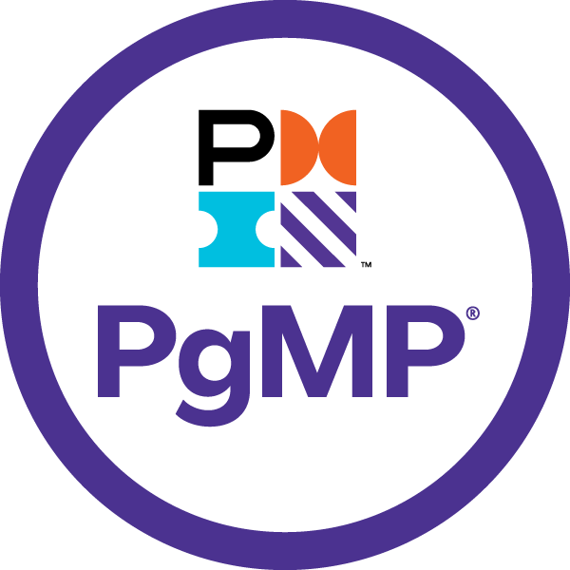

Sriram

# Sriram



I have been involved in IT Software development since 1997. I have unique combination of process, technical and industrial skills. As a Digital Leader, I have expert level of knowledge in agile and practices with this combination I can help process and technology people, understand the agile world.

The “**Program** **Management Excellence”** book comprises of Program Management. One in All, All in One & Key to Success.

My agile journey started in 2011, when I was a part of Tata Consultancy Services. I practiced scrum and agile methods thoroughly over several years and my teams are highly successful in delivering products using agile techniques.

I am proficient in agile engineering, coaching practices and SAFe consulting practices. I have more than 5 years of experience as a senior architect cum senior manager in development. I religiously follow key agile engineering practices like TDD, Refracting, CI and Collective Ownership. Worked in USA, UK for TCS, AtoS, Cognizant & IBM - Agile customers, which creates a global agile experience.

I moved back to India in 2016 and created agile websites and released books related to Scrum Alliance Professional, Agile Coaching and Implementing SAFe 5.0 practices.

Throughout my agile journey, I have been associated the agile professionals, who have helped and mentored me in the journey where sky is the limit.

Place: Dubai, UAE – Middle East Email: digitalcloudguru@gmail.com

# Table of Contents

Contents

Sriram 2

Table of Contents 3

Program Management – Fourth Edition 4

1. Introduction to Program Management 6

2. Program Management Performance Domains 20

3. Program Strategy Alignment 27

4. Program Benefits Management 35

5. Program Stakeholder Engagement 45

6. Program Governance 63

7. Program Life Cycle Management 75

8. Program Integration Management 83

9. Program Management Supporting Process 88

10. Program Management Glossary 96

# Program Management – Fourth Edition

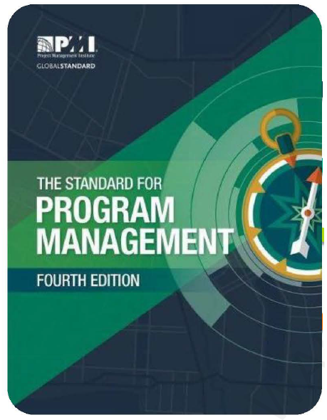

The Purpose of Standard for Program Management

* Principles of Program Management
* Good Practice of Program Management
* Understand the role of a Program Manager
* Understand the code of Ethics and Professional

The Standard for Program Management is also intended to provide a common understanding of the role of a program manager in general, and especially when interacting with: -

* Portfolio managers whose portfolio(s) include the program or its components;
* Project managers whose projects are part of the program;
* Program sponsors and other members of the program steering committee. This committee may be referred to as
* a program or portfolio governance board;
* Program or project management office;
* Program team members working on the program or on other subsidiary programs;
* Program beneficiaries; and
* Other stakeholders or stakeholder groups (e.g., organizational executives, business partners, clients, suppliers,
* vendors, leaders or political groups) that may influence the program.

## 1. Introduction to Program Management

**1.1 Terms in Program Management**

* A **Project** is a temporary endeavor undertaken to create a unique product, service or result.
* A **Program** is a group of related projects, subprograms, and program activities managed in a coordinated way to obtain benefits not obtainable from managing them individually.
* **Program Activities** are Work processes or activities performed to support a program
* **Subsidiary Programs** are the Programs Sponsored and conducted to pursue a subset of goals important to the primary program
* **Components** are projects, subsidiary programs or other related activities conducted to support a program
* A **Portfolio** is a collection of projects, programs, and operations managed as a group to achieve strategic objectives.

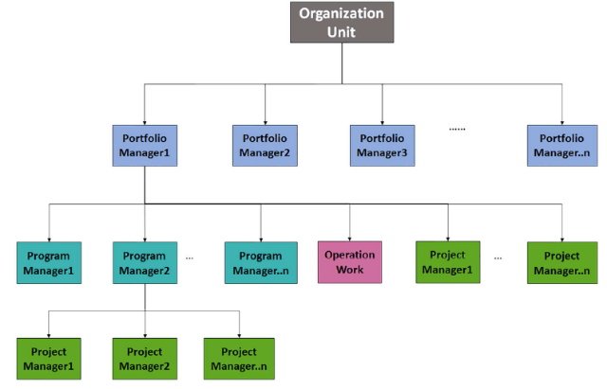

**1.2 What is Program Management?**

Program management is the application of knowledge, skills, and principles to a program to achieve the program objectives and to obtain benefits and control not available by managing program components individually. It involves aligning multiple components to achieve the program goals and allows for optimized or integrated cost, schedule, and effort. The program benefits can be realized incrementally thought the duration of the program or may be realizes at or after the end of the program

**Benefits of Program Management: -**

A benefit is the gains and assets realize by the organization and other stakeholders as the result of outcomes delivered by the program.

* To enhance the current capabilities
* New products or services
* Facilitating change
* Creating or maintaining assets
* Offering new products and services
* Behaviors

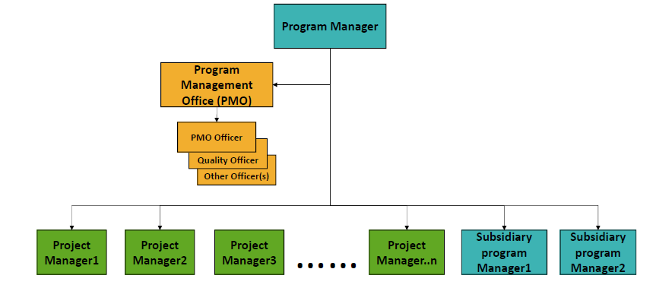

**1.3 Program Life Cycle**

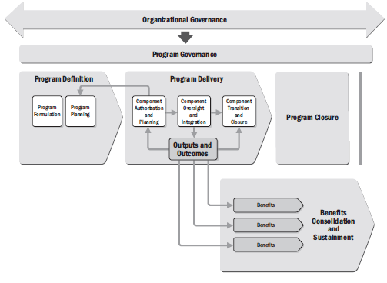

**Program Definition**

**Program Delivery**

**Program Closure**

**Program Benefits**

**1.4 Relationships among Project, Programs & Portfolio Management & The Organizational Project Management (OPM)**

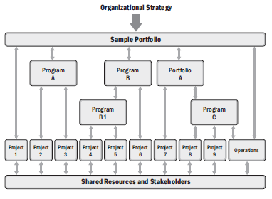

Programs and projects, as significant elements of an organization's portfolio, are conducted to produce the outputs and outcomes required to support an organization's strategic objectives.

The program manager overseas and analyzes component interdependencies to determine the optimal approach for managing program components

**Portfolio management** is the centralized management of one or more portfolios to achieve strategic objectives. Portfolio management focuses on the establishment and use of good practices when choosing programs or projects to sponsor, prioritizing their goals and work, and ensuring that they can be adequately resourced.

**Program management** is the application of knowledge, skills, and principles to a program to achieve the program objectives and to obtain benefits and control not available by managing program components individually. Program management focuses on the coordinated and effective delivery of benefits derived from the pursuit of a group of projects and other programs whose outcomes are related.

**Project management** is the application of knowledge, skills, tools, and techniques to project activities to meet the project requirements. Project management focuses on the efficient delivery of the outputs and outcomes required by organizations within defined constraints of time, cost, and specifications.

OPM provides a framework in which portfolio, program, and project management practices are integrated to achieve strategic objectives. OPM supports the coordinated practice of portfolio, program, and project management by linking portfolio, program, and project management principles and practices. OPM is employed to produce improved performance, better results, and sustainable strategic benefits for organizations.

**Comparative Overview of Project, Program & Portfolio Management**

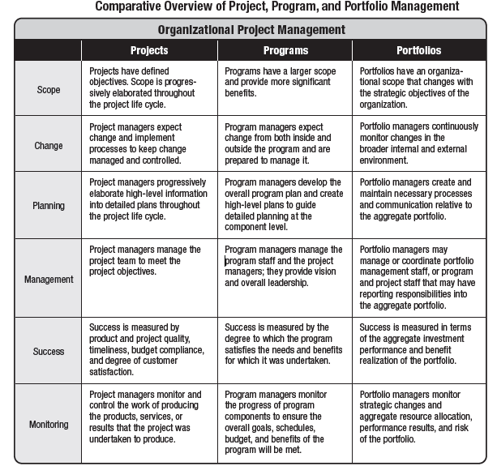

**The Interaction among Portfolio, Program & Project Management**

**Portfolio Managers:** Ensure that programs and projects are selected, prioritized, and staffed according to an organization's strategic plan for realizing the desired organizational value.

**Program Managers:** Focus on delivering organizational benefits aligned with the organization's strategic plan through the coordinated management of projects, subsidiary programs, and other supportive work.

**Project Manager:** Focus on the generation of the specific outputs and outcomes required by an organization.

**The Relationship between Program and Portfolio Management**

* Collaborative Function of the organization.
* Both works together to ensure that benefits desired or required by an organization are effectively and efficiently delivered.

**The Relationship between Program and Project Management**

* Collaborative Function of the organization.
* Both works together to define viable strategies for pursuing program goals and thereby delivering program benefits

**1.5 The Relationships among Organizational Strategy, Program & Operations Management**

* It is important that program managers establish collaborative, mutually supportive relationships with those responsible for managing operations within an organization.
* Together, program and operational managers are responsible for ensuring the balanced and successful execution of an organization's strategic objectives

**1.6 Business Value**

* **Portfolio management** ensures that an organization’s programs, projects, and operations are aligned with an organization’s strategy.
* It allows organizations to define how they will pursue their strategic goals through programs and projects, and how those programs and projects will be supported by human, financial, technical, or material resources. In so doing, portfolio management optimizes the pursuit of business value.
* **Program management** enables organizations to more effectively pursue their strategic goals through the coordinated pursuit of projects, subsidiary programs, and other program-related activities.
* Program management seeks to optimize the management of related component projects and programs to improve the generation of business value.
* **Project management** enables organizations to more efficiently and effectively generate outputs and outcomes required for the pursuit of an organization’s objectives by applying knowledge, processes, skills, tools, and techniques that enhance the delivery of outputs and outcomes by projects.
* Project management seeks to optimize the delivery of business value by improving the efficiency of organizations as they deliver new products, services, or results.

**1.7 Role of the Program Manager**

Program Manager is the person authorized by the performing organization to lead the team or team responsible for achieving the objectives. Program Managers work to ensure that projects, other programs, and program activities are organized and executed in a consistent manner and fulfilled within the established standards

**Program Leadership:** Maintains responsibility for the leadership, conduct, and performance of a program, and for building a program team that is capable of achieving program objectives and delivering anticipated program benefits.

**Meet Organization’s Strategic Objectives:** Ensure that program components are adapted as required to meet the organization’s strategic objectives.

**Optimize delivery of Program benefits:** Managing uncertainty, navigating complexity, and implementing change in the program environment, to optimize the delivery of program benefits.

**Management of Complex Issues:** Managing or coordinating the management of complex issues that may arise as programs seek to deliver benefits.

**Monitor the outputs and outcomes:** Monitor the outputs and outcomes of a program’s component activities and ensure that the program adapts appropriately to them.

**Interaction with Components Managers:** Interact with program managers to provide support and guidance on individual initiatives conducted to support a program

**Interaction with Operational Managers:** Interact with operational managers and stakeholders to ensure that programs receive appropriate operational support and that benefits delivered by the program can be effectively sustained

**Interact with Portfolio Managers:** Interact with portfolio managers to ensure that programs are provided with the appropriate resources and priority

**Integrate the program components**: Integrate the program components deliverables, outcomes, and benefits into the programs end product, services or results such that the program delivers its intended benefits

**Collaborate with Governance Bodies:** Collaborate with governance bodies, sponsors and the program management office to ensure the program’s continued alignment with organizational strategy and ongoing organizational support

**Core responsibilities of a Program Manager**

* Daily program management throughout the program lifecycle
* Define the program governance
* Plan the overall program and monitor the progress
* Manage the program’s budget
* Manage risks and issues and take corrective measurements
* Coordinate the projects and their interdependencies
* Manage and utilize resources across projects
* Manage stakeholders’ communication
* Align deliverables to the program’s outcome
* Manage the main program documents

**Daily & Monthly Responsibilities of Program Manager**

* Work closely with project sponsor, cross-functional teams, and assigned project managers to plan and develop scope, deliverables, required resources, work plan, budget, and timing for new initiatives
* Manage program and project teams for optimal return-on-investment, and coordinate and delegate cross-project initiatives
* Identify key requirements needed from cross-functional teams and external vendors
* Develop and manage budget for projects and be accountable for delivering against established business goals/objectives
* Work with other program managers to identify risks and opportunities across multiple projects within the department
* Analyze, evaluate, and overcome program risks, and produce program reports for management and stakeholders

**1.7.1 Program Manager Competencies**

* Communication Skills
* Stakeholder Engagement Skills
* Change Management Skills
* Leadership Skills
* Analytical Skills
* Integration Skills

**Performance Competencies of Program Manager**

* Defining
* Initiating
* Planning
* Executing
* Monitoring & Controlling
* Closing

**Personal Competencies of Program Manager**

* Communicating
* Leading
* Building Relationship
* Negotiating
* Thinking Critically
* Facilitating

**1.8 Role of the Program Sponsor**

* Provides Valuable Guidance
* Support the Program
* Assist the Program Manager
* Individual or a group
* Provides Resources
* Securing Fund
* Enabling Success

**1.9 Role of the Program Management Office**

A program management office is a management structure that standardizes the program-related governance processes and facilitates the sharing of resources, methodologies, tools, and techniques. A program management office often also supports training and other organizational change management activities. Program management offices may be established within an individual program to provide support specific to that program, or independent of an individual program to provide support to one or more of an organization’s programs.

When established as part of a program, a program management office is an important element of the program’s infrastructure and an aid to the program manager. It may support the program manager with the management of multiple projects and program activities, for example, by:

* Defining standard program management processes and procedures that will be followed
* Providing centralized support for managing changes and tracking risks, issues, and decisions
* Providing training to ensure that standards and practices are well understood
* Supporting program communications
* Supporting program level change management activities
* Conducting program performance analyses
* Supporting management of the program schedule and budget
* Defining general quality standards for the program and its components
* Supporting effective resource management
* Providing support for reporting to leadership and program steering committees
* Supporting document and knowledge transfer

**Program Vs Project Management**

Program and Project differences are: - Uncertainty, Change, Complexity & Success

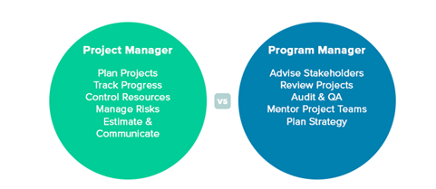

## 2. Program Management Performance Domains

**2.1 Introduction to Program Management Performance domains**

Program Management Performance domains are:

1. Program Life Cycle Management

2. Program Strategy Alignment

3. Program Benefits Management

4. Program Stakeholder Engagement

5. Program Governance

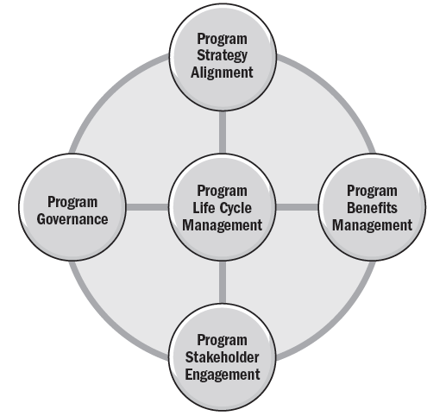

**Program Strategy Alignment**: Performance domain that identifies program outputs and outcomes to provide benefits aligned with the organization’s goals and objectives. i.e., Identifying the opportunities and benefits to achieve the organization’s strategic objectives through program implementation.

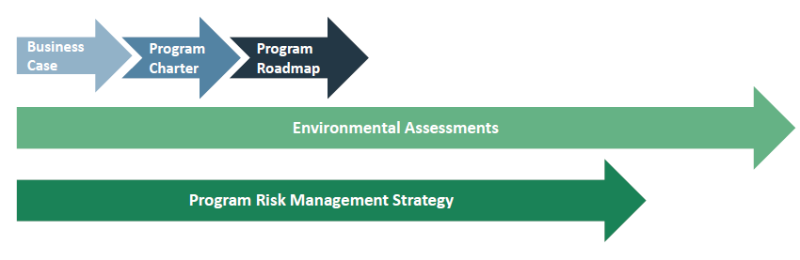

**Program Benefits Management:** Performance domain that defines, creates, maximizes, and delivers the benefits provided by the program. i.e., Defining, creating, maximizing, delivering and sustaining the benefits of the program.

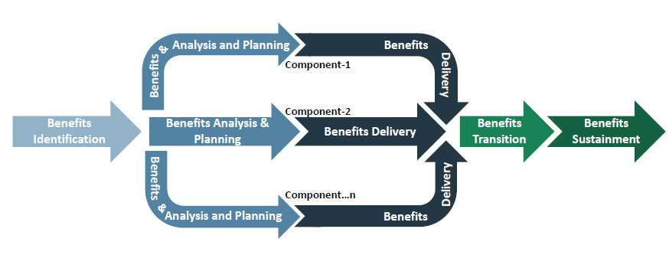

**Program Stakeholder Engagement:** Performance domain that identifies and analyzes stakeholder needs and manages expectations and communications to foster stakeholder support. i.e., Capturing and understanding stakeholder needs, desires and expectations and analyzing the impact of the program on stakeholders, gaining and maintaining stakeholder support, managing stakeholder communications, and mitigating stakeholder resistance.

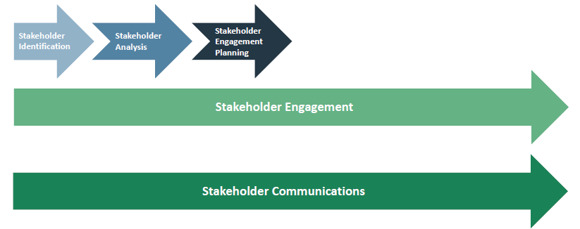

**Program Governance:** Performance domain that enables and performs program decision making, establishes practices to support the program, and maintains program oversight. i.e., Establishing processes and procedures for maintaining program management oversight and decision-making support for applicable policies and practices throughout the program.

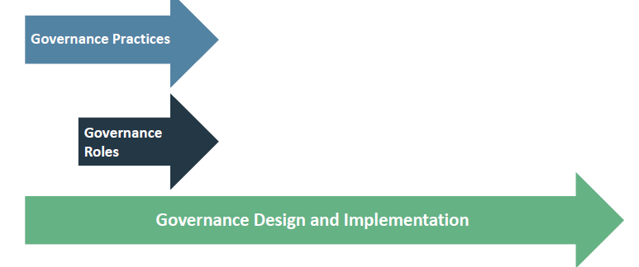

**Program Life Cycle Management:** Performance domain that manages program activities required to facilitate effective program definition, program delivery, and program closure. i.e., Managing all of the program activities related to program definitions, program benefits delivery and program closure.

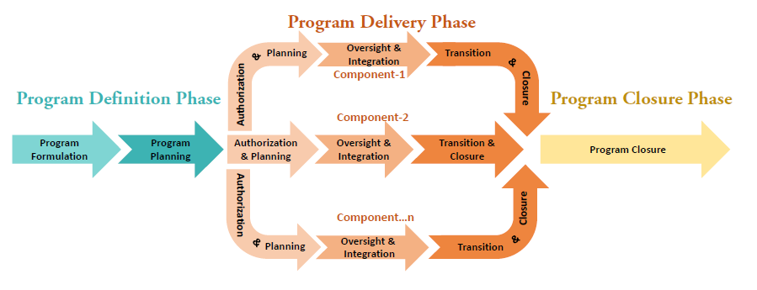

**2.2 Program Life Cycle Phases**

Manage all of the program activities related to program definition, program benefits, and program closure.

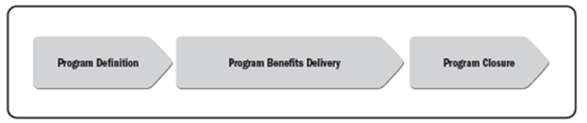

In program life cycle phases, Individual subprograms, projects, and other work make up the program life cycle and are collectively referred to as program components

**Program Definition:** The activities typically occur as the result of an organization’s plan to fulfil strategic objectives or achieve a desired state within an organization’s portfolio. The primary purpose of the program definition phase is to progressively elaborate the strategic objectives to be addressed by the program, define the expected program outcomes, and see approval for the program

**Program Benefits Delivery:** Throughout this iterative phase, program components are planned, integrated, and managed to facilitate the delivery of the intended program benefits

**Program Closure:** The purpose of this phase is to execute a controlled closure of the program

When projects are considered temporary endeavors of relatively short duration, whereas programs often span considerably long durations – multiple years and, in some cases, decades. Regardless of duration, all programs follow a similar trajectory.

A Program is initiated and defined during program definition phase. It is implemented in the program benefits of delivery phase, where individual components(projects) are initiated, implemented, transitioned, and closed, while benefits are delivered, transitioned, and sustained. The program is transitioned and closed, or the work us transitioned to another program closure phase.

**2.3 Program Activities**

The collection of work undertaken in a program for the purpose of the overall program implementation is collectively known as activities. For example, project risk management activities focus on the individual component projects while program risk management incorporates project-level risk to address the overall risk to the program.

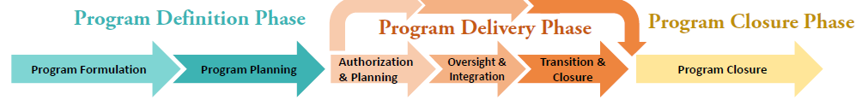

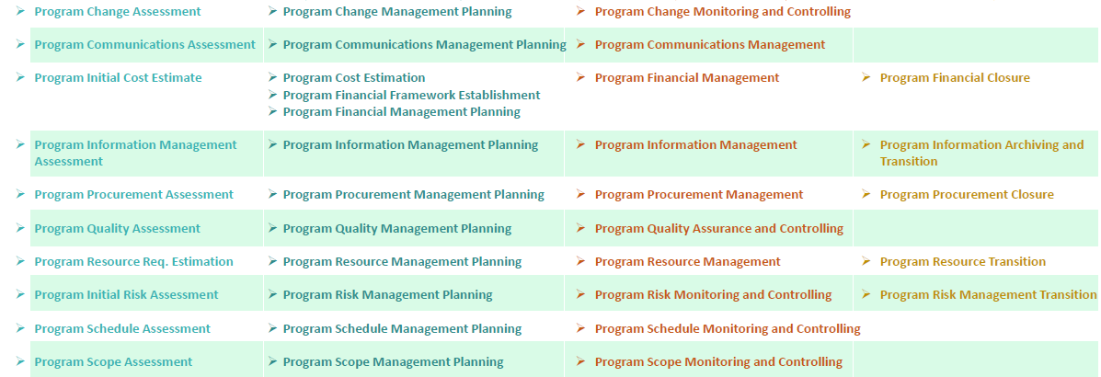

**2.4 Program Management Supporting Process**

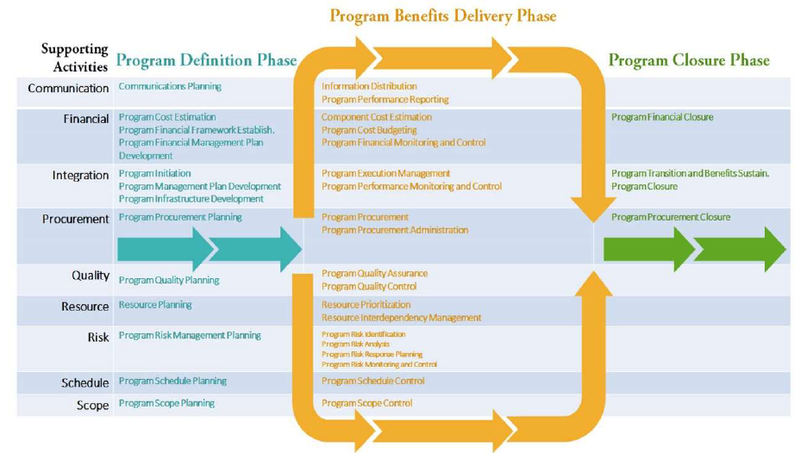

## 3. Program Strategy Alignment

Programs are designed to align with organizational strategy and ensure organizational benefits are realized. To accomplish this, program managers require strategic visioning and planning skills to align program goals with the long-term goals of the organization.

Project Managers lead and direct the work on their components, it is the program manager’s responsibility to ensure alignment of the individual plans with the program goals and intended benefits in support of the achievement of the organization strategy.

The relationship between the Program Management Plan and other strategy related documents are

* Program Business Case
* Program Charter
* Program Roadmap

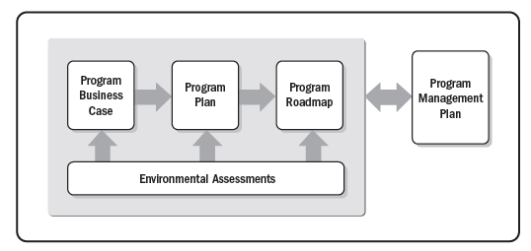

All of these elements become the basis for the development of a comprehensive program management plan that establishes the outline use to achieve the organization strategy and objectives through program implementation

**3. Program Strategy Alignment Domain Elements**

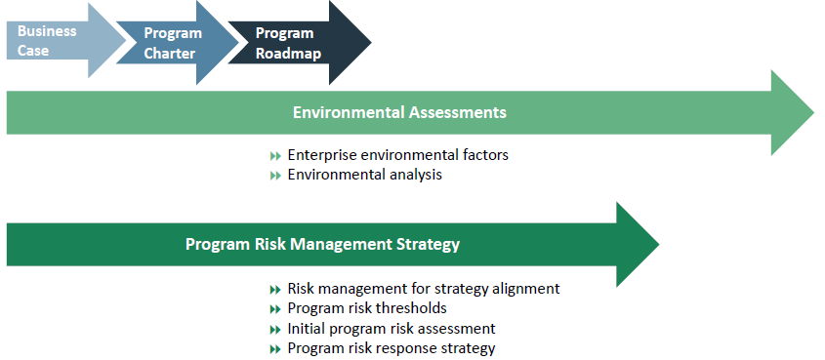

**Major Activities in Strategy Alignment**

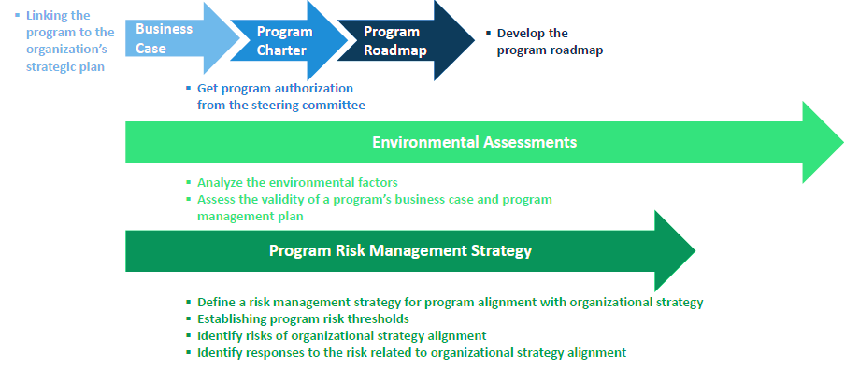

**Major Artifacts in Strategy Alignment**

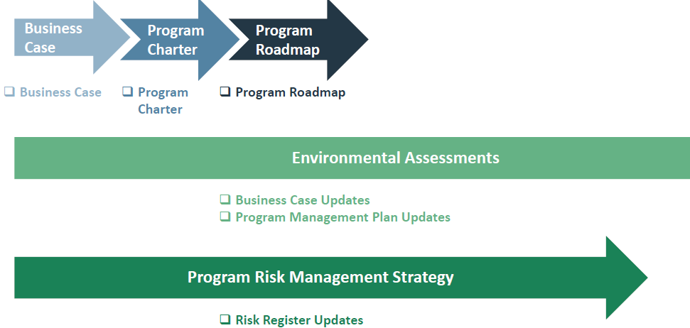

**3.1 Artifacts - 1. Program Business Case**

The Business case is developed to assess the program’s balance between cost and benefit. The business case may be basic and high level or detailed and comprehensive. It includes key parameters used to assess the objectives and constraints for the intended program.

The business case may include the detail about:

* Problems or opportunities
* Business and operation impact
* Cost benefit / Alt. / Financial analysis
* Profits & Benefits
* Market demand
* Social need and env. influence
* Legal implication
* Risk and constraints
* Time to market
* Alignment with strategic objective

**3.2 Artifacts - 2. Program Charter**

A Program Charter contains the following elements

* Program justification and vision
* Relationship strategic objectives
* Outcomes
* High level program scope
* Planned benefits
* Assumptions, constraints, risks and Issues
* Component structure
* Key milestones
* Cost and resource needs
* Key identified stakeholders
* Success factors

**3.3 Artifacts - 3. Program Roadmap**

A chronological representation of a programs intended direction

* Reflects the pace at which benefits are realized
* Shows the key dependencies
* Provides a high-level view

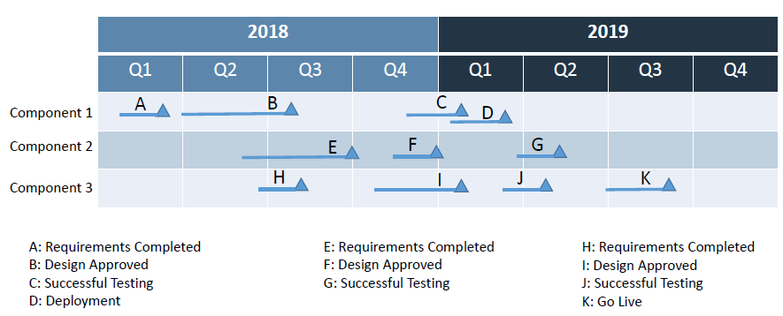

**3.4 Environmental Assessments**

These are often influencing inside and outside of the program that have a significant impact on the program’s ultimate success. Some of the influences from outside the program are internal to the larger organization, and some come from completely external sources.

**A. Enterprise Environmental Factors**

The Enterprise Environmental Factors are:

|  |  |
| --- | --- |
| * Business environment * Market * Funding * Resources * Industry * Health, Safety & Environment * Economy | * Cultural & Geographic Diversity Regulatory * Legislative * Growth * Supply base * Technology * Risk |

**B. Environmental Analysis**

The Environmental Analysis that may be used to assess the validity of the business case and program plan. Consideration of the results from one or more environmental analyses enables the program manager to highlight factors that have potential for impacting the program.

The sample environment analysis is given below: -

**(I) Comparative advantage analysis**

When conducting comparative analysis against a strategic initiative and or business case, it is important to consider that competing efforts may reside within or external to the organization. A typical business case includes analysis and comparison against real or hypothetical alternative efforts. Where appropriate, this technique may also include what-if analyses to illustrate how the program objectives and intended benefits could be achieved by other means

**(ii) Feasibility study**

Using the business case, organization goals, and other existing initiatives as a base, this process assesses the feasibility of the program within the organization’s financial, sourcing, complexity, and constraint profile. This analysis contributes to the body of information that decision makers require to approve or deny the program proposal.

**(iii) SWOT analysis**

To analyze the strengths, weakness, opportunities, and threats (SWOT) of the endeavor provides information for developing the program charter and program plan

**(iv) Assumption’s analysis**

Assumptions are factors that, for planning purposes, are considered true, real or certain. Assumptions affect all aspects of the program and are part of the progressive elaboration of the program.

**(v) Historical information analysis**

Previously completed programs may be a source of lessons learned and the best practices for new programs. Historical information includes all artifacts, metrics, risks, and estimations from previous programs, projects, and ongoing operations that may be relevant to the current program. Historical information describing the successes, failures, and lessons learned is particularly important during program definition.

**3.5 Program Risk Management Strategy**

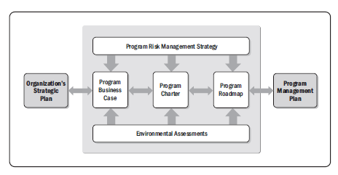

**Risk Management for Strategy Alignment**

Determining how risks will be communicated to strategic levels of the organization

**Program Risk Thresholds**

Risk threshold is the measure of the degree of acceptable variation around a program objective that reflects the risk appetite of the organization and program stakeholders.

**Initial Program Risk Assessment**

While program risk management is conducted throughout the life of the program, the initial program risk assessment, prepared during program definition, offers a unique opportunity to identify risks to organizational strategy alignment.

**Program Risk Response Strategy**

Program risk response strategy combines the elements of the risk thresholds and the initial risk assessment into a plan for how program risks will be managed effectively and consistently throughout the life of the program. For each identified risk, the risk thresholds can be used to identify the specific response strategy based on a number of rating criteria.

As an example, for an organization that views 5 % schedule variance as acceptable: -

Risk threshold—5% schedule delay, Risk rating—no significant risk & Response strategy—accept.

## 4. Program Benefits Management

Program Benefits Management comprises a number of elements that are central to program success. Program Benefits Management includes processes to clarify the program’s planned benefits and intended outcomes and includes processes for monitoring the program’s ability to deliver against these benefits and outcomes.

The purpose of Program Benefits Management is to focus program stakeholders (program sponsors, program manager, project managers, program team, program steering committee, and others) on the outcomes and benefits to be provided by the various activities conducted during the program’s duration.

To do this, the program manager employs Program Benefits Management in order to continually: -

* Identify and assess the value and impact of program benefits,
* Monitor the interdependencies among the outputs being delivered by the various components within the program and how those outputs contribute overall to the program’s benefits,
* Analyze the potential impact of planned program changes on the expected benefits and outcomes,
* Align the expected benefits with the organization’s goals and objectives, and
* Assign responsibility and accountability for the realization of benefits provided by the program and ensure that the benefits can be sustained.

**Benefits Management Domain Phases**

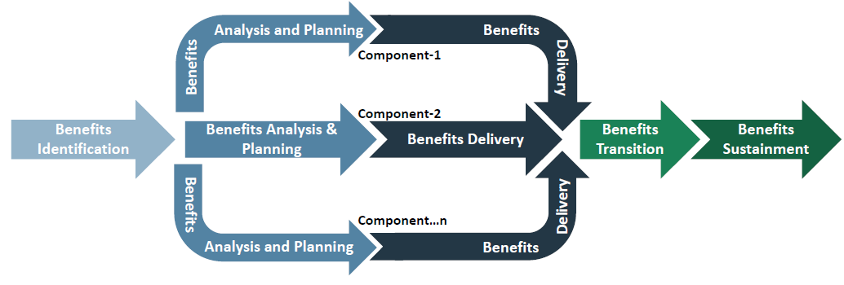

**Major Activities**

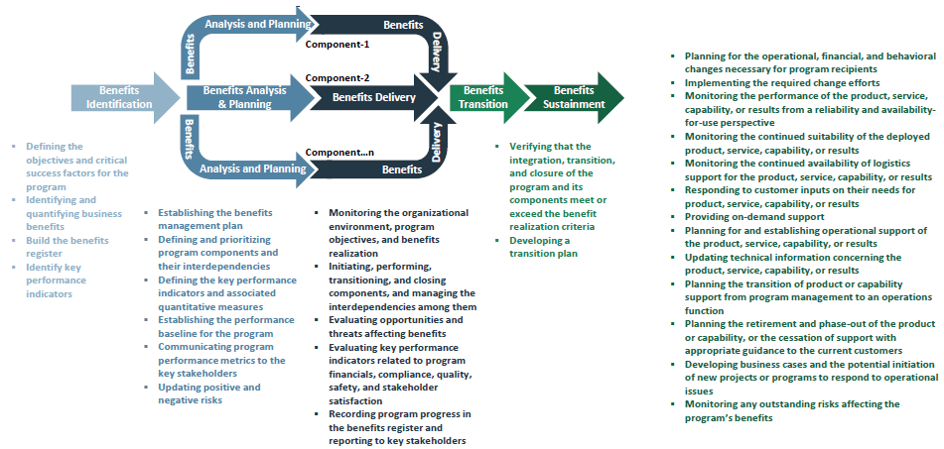

**Major Artifacts**

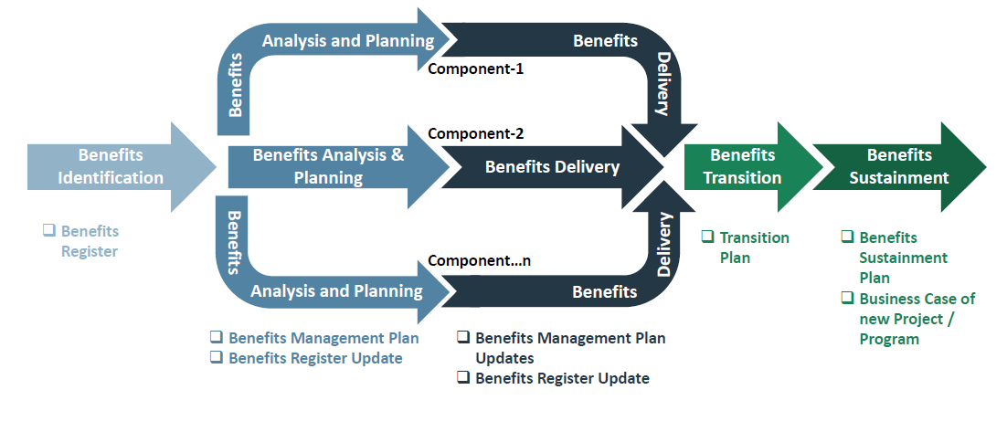

**4.1. Benefits Identification**

The purpose of the benefits identification phase is to analyze the available information about organizational and business strategies, internal and external influences, and program drivers to identify and qualify the benefits that program stakeholders expect to realize.

**Benefits Register**

Benefits register includes: -

* List of planned benefits
* Mapping of the planned benefits to the program components
* Description of how each benefit will be measured
* Key performance indicators and thresholds
* Risk assessment and probability & Status or progress indicator
* Target dates and milestones for benefits achievement
* Person, group, or organization responsible for delivering each benefit
* Establishment of processes for measuring progress against the benefits plan
* Tracking and communications processes necessary to record program progress and report to stakeholders

**2. Benefits Analysis & Planning**

The purpose of the benefits analysis and planning phase is to establish the program benefits management plan and develop the benefits metrics and framework for monitoring and controlling both the components and the measurement of benefits within the program. Activities that make up benefits analysis and planning include: -

* Establishing the benefits management plan that will guide the work through the remainder of the program,
* Defining and prioritizing program components and their interdependencies,
* Defining the key performance indicators and associated quantitative measures required to effectively monitor the delivery of program benefits,
* Establishing the performance baseline for the program and communicating program performance metrics to the key stakeholders, and
* Updating positive and negative risks to benefits as more information becomes known

**Benefits Management Plan**

Benefits management plan includes:

* Benefit definition and associated assumptions and determination of how each benefit will be achieved
* Linkage between components outputs and the planned program outcomes
* Metrics and procedures to measure benefits
* Roles and responsibilities required to manage the benefits
* How the resulting benefits and capabilities will be transitioned into an operational state
* How the resulting capabilities will be transitioned to the individuals, groups, or organizations
* Process for managing the overall benefits management effort

**Benefits Management & the Program Roadmap**

Program benefits management establishes the program architecture that maps how the components will deliver the capabilities and outcomes that are intended to achieve the program benefits. The program roadmap defines the structure of the program components by identifying the relationships among the components and the rules that govern their inclusion. The program roadmap describes evolving aspects of the program including incremental benefits delivery.

**Benefits Register Update**

The benefits register, initiated during benefits identification, is updated during benefits analysis and planning. At this time, program benefits are mapped to the program components based on the program roadmap. The benefits register is then reviewed with the appropriate stakeholders to define and approve key performance indicators and other measures that will be used to monitor program performance.

**3. Benefits Delivery**

The purpose of the benefits delivery phase is to ensure that the program delivers the expected benefits, as defined in the benefits management plan. As the program is implemented, risks affecting benefits may be realized, may need to be updated, or may become obsolete; additionally, new risks and updated ones should be included in the benefits register with the associated benefits. Activities that make up benefits delivery include: -

* Monitoring the organizational environment (including internal and external factors), program objectives, and benefits realization to ensure that the program remains aligned with the organization’s strategic objectives;
* Initiating, performing, transitioning, and closing components, and managing the interdependencies among them;
* Evaluating opportunities and threats affecting benefits, including updating the benefits register for new opportunities and risks affecting benefits, and updating realized or obsolete risks affecting benefits;
* Evaluating key performance indicators related to program financials, compliance, quality, safety, and stakeholder satisfaction in order to monitor the delivery of benefits; and
* Recording program progress in the benefits register and reporting to key stakeholders as directed in the program communications management plan.

**Benefits and Program Components**

Each component should be initiated at the appropriate time in the program and integrated to incorporate its output to the program as a whole. The initiation and closure of these components are significant milestones in the program roadmap and schedule. The milestones signal the achievement and delivery of incremental benefits.

**Benefits Management Plan & Benefits Register Update**

Already discussed above, in case of any changes we have to update.

**4. Benefits Transition**

The purpose of the benefits transition phase is to ensure that program benefits are transitioned to operational areas and can be sustained once they are transferred. Value is delivered when the organization, community, or other program beneficiaries are able to utilize these benefits.

Activities that make up benefits transition include:

* Verifying that the integration, transition, and closure of the program and its components meet or exceed the benefit realization criteria established to achieve the program’s strategic objectives; and
* Developing a transition plan to facilitate the ongoing realization of benefits when turned over to the impacted operational areas.
* Benefits transition ensures that the scope of the transition is defined, the stakeholders in the receiving organizations or functions are identified and participate in the planning, the program benefits are measured and sustainment plans are developed, and the transition is executed.

Benefits transition activities may include: -

* Evaluation of program and program component performance against applicable acceptance criteria, including
* key performance indicators;
* Review and evaluation of acceptance criteria applicable to delivered components or outputs;
* Review of operational and program process documentation;
* Review of training and maintenance materials (if they apply);
* Review of applicable contractual agreements;
* Assessment to determine if resulting changes have been successfully integrated;
* Activities related to improving acceptance of resulting changes (workshops, meetings, training, etc.);
* Transfer of risk(s) affecting the benefits transitioned to the receiving organization;
* Readiness assessment and approval by the receiving person, group, or organization; and
* Disposition of all related resources.

**Transition Plan**

Transition plan include: -

* Checklists to review the organization readiness
* Plan to deploy the product, service, capability, or results
* Rollback plan
* Probable failure scenarios with contingency planning

**Transition Highlights**

* Process and Procedure
* Resource Capabilities (training, coaching, secondment, hiring,)
* Internal Readiness
* External Readiness
* Contingency plans (Failure scenarios, Contingency, Rollback plan)
* Deployment

**5. Benefits Sustainment**

The purpose of the benefits sustainment phase is the ongoing maintenance activities performed beyond the end of the program by receiving organizations to ensure continued generation of the improvements and outcomes delivered by the program. As the program is closed, responsibility for sustaining the benefits provided by the program may pass to another organization or another program. Benefits may be sustained through operations, maintenance, new components, or other efforts. A benefits sustainment plan should be developed prior to program closure to identify the risks, processes, measures, metrics, and tools necessary to ensure the continued realization of the benefits delivered.

**Benefits Sustainment Plan**

Benefits sustainment plan include: -

* Operational, financial, and behavioral changes necessary for program recipients to continue monitoring performance
* Metrics to measure the performance of the product, service, capability, or results from a reliability, availability for- use, and suitability perspectives
* Processes and procedures to operate for the product, service, capability, or results
* Processes to respond to operational issues with the deployed product, service, or capability, or results
* Process to monitor any outstanding risks affecting the program’s benefits

**Benefits Management Relationship with Program Life Cycle**

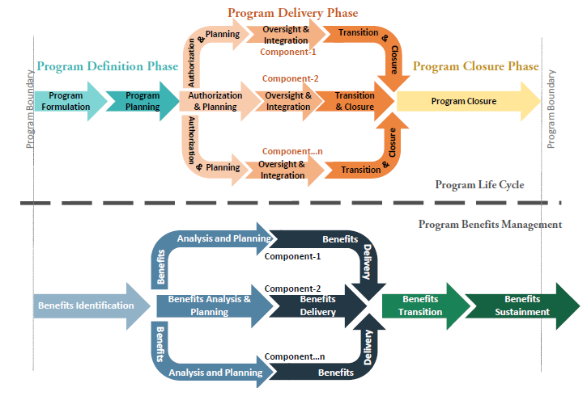

## 5. Program Stakeholder Engagement



**What is Program stakeholders Engagement?**

Program Stakeholder Engagement is the performance domain that identifies and analyzes stakeholder needs and manages expectations and communications to foster stakeholder support.

Activities includes: -

* Stakeholder Identification
* Stakeholder Analysis
* Stakeholder Engagement Planning
* Stakeholder Engagement
* Stakeholder Communications

**Who are all the stakeholders in your project?**

A stakeholder is an individual, group, or organization that may affect, be affected by, or perceive itself to be affected by a decision, activity, or outcome of a project, program, or portfolio.

Stakeholders may be internal or external to the program and may have a positive or negative impact on the outcome of the program. Program and project managers need to be aware of the stakeholders’ impact and level of influence to understand and address the changing environments of programs and projects.

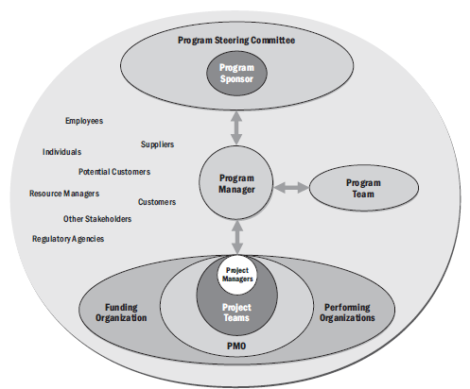

**Internal stakeholders Examples:**

* Program Sponsor
* Program Manager
* Program team
* Steering Committee
* Contracting department team (if the program or its component has vendors involved)
* Business departments (operation, sales, and others, depend on the program scope)
* Information Technology (IT) department
* HR department (for instances, if new recruitment is required, or performance evaluation is different for the program team)
* Other concerned departments (depends on the program scope)

**External stakeholders Examples:**

* Customers & Vendors & Recruitment Agents
* Standard Authority (based on the program industry)
* Environment Activists (depends on the program scope)
* May be the Public (depends on the program scope)

**Stakeholder Engagement Domain**

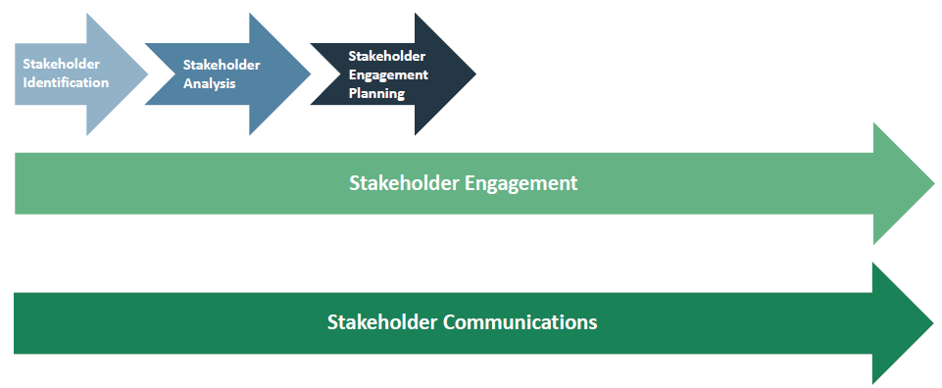

**Stakeholder Major Activities**

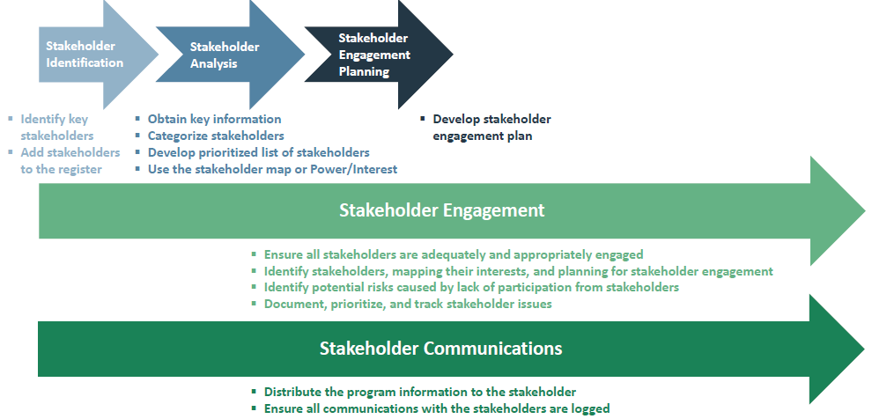

**Stakeholder Major Artifacts**

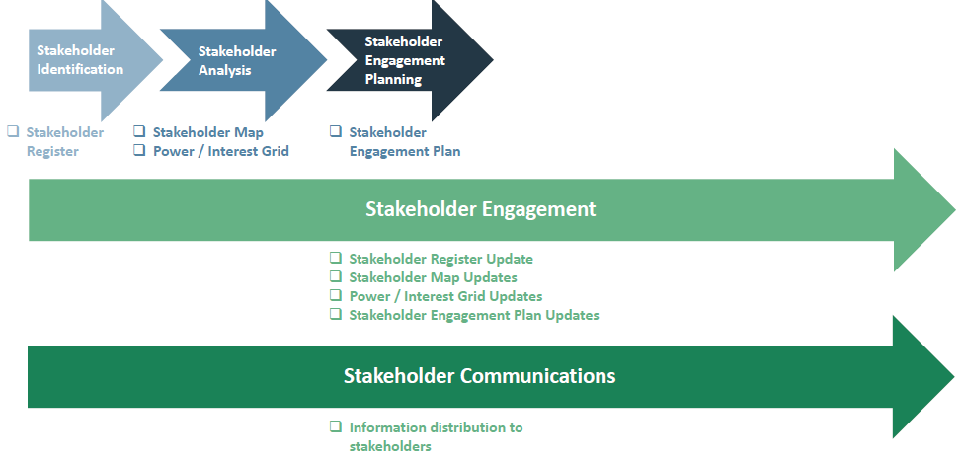

**5.1 Stakeholder Identification**

Program stakeholder identification aims to systematically identify all key stakeholders (or stakeholder groups) in the stakeholder register.

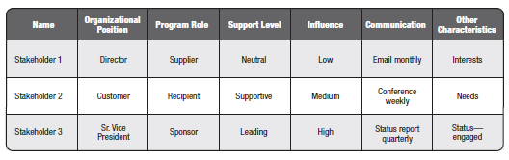

**Stakeholder Identification is an iterative process and the stakeholder register should be updated regularly.**

**Stakeholder Identification Methods**

* Brainstorming
* Focus Groups
* Historical Information
* Expert Judgement
* Interviews
* Surveys & Questionaries
* Stakeholder Register

**Stakeholder Register**

The Stakeholder Register includes:

* Stakeholder name, contact
* Stakeholder role
* Relationship to the program
* Ability to influence the program outcome
* Degree of support to the program
* Stakeholder required reporting level

**5.2 Stakeholder Analysis**

Program Stakeholder analysis aims to categorize all listed stakeholder, and highlight differences in their needs, expectations, or influence in order to better understand the organizational culture, politics, and concerns relate to the program, as well as the overall impact of the program.

**Methods**

* Focus Groups
* Individual Interviews
* Historical Information
* Questionaries & Surveys

**Stakeholder Map**

* Used in the complex programs
* Identify the need for interactions with stakeholders
* Potential partnerships among stakeholders
* Used to remind teams of which stakeholders need to be engaged

**Power / Interest Grid**

* Low interest and low power
* High interest and low power
* Low interest and high power
* High interest and high power

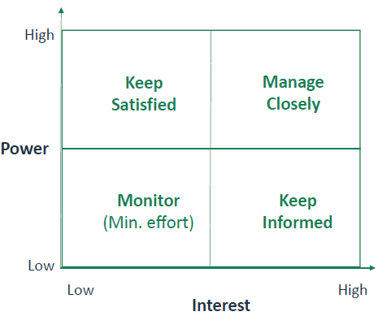

**5.3 Stakeholder Engagement Planning**

The stakeholder engagement planning activity outlines how all program stakeholders will be engaged throughout the duration of the program. The stakeholder register and stakeholder map are analyzed with consideration of the organization’s strategic plan, the program charter, and program business case to understand the environment in which

the program will operate.

As part of the stakeholder analysis and engagement planning, the following aspects for each stakeholder are taken into consideration: -

* Organizational culture and acceptance of change,
* Attitudes about the program and its sponsors,
* Relevant phase(s) applicable to stakeholder’s specific engagement,
* Expectation of program benefits delivery,
* Degree of support or opposition to the program benefits, and
* Ability to influence the outcome of the program

**Stakeholder Engagement Plan**

The Stakeholder Engagement Plan includes:

* Detailed strategy for effective stakeholder engagement, based on current situation.
* Stakeholder engagement guidelines
* Insight on how the stakeholders is engaged in various components of the program
* The metrics used to measure the performance of stakeholder engagement activities

**5.4 Stakeholder Engagement**

* Ensure all stakeholders are adequately and appropriately engaged
* Identify stakeholders, mapping their interests, and planning for stakeholder engagement
* Identify potential risks caused by lack of participation from stakeholders
* Document, prioritize, and track stakeholder issues

**5.5 Stakeholder Communications**

* Distribute the program information to the stakeholder
* Ensure all communications with the stakeholders are logged

**Stakeholder Engagement Relationship with Program Life Cycle**

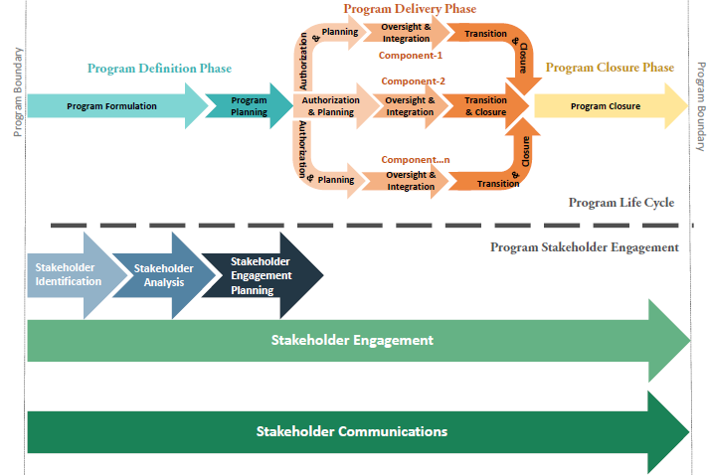

**Stakeholder Discussions**

**How would you manage Stakeholders?**

* Understand their success criteria
* Provide Weekly Status Reports
* Establish Weekly team meetings and executive steering committees
* Define clear roles and responsibilities

**What are the key components of successful project?**

* Balancing scope, schedule and cost
* Understanding success measures of the client
* Ensuring Quality
* Tracking risks and issues

**How do you measure project success?**

* By validating that my sponsor is satisfied based on the fact that we have met all of the project requirements
* By being able to measure that the project has satisfied all the Key Performance Indicator
* By having all the major stakeholders satisfied that we have met our goals
* By conducting the post project lessons learned to make sure that no anomalies show up there
* By make sure that all the project deliverables are available in online

**Can you successfully deal with underperforming employees?**

I will find-out the root cause for the underperformance, try to find if the reasons for underperformance is under my control if so I will handle it heads-on. If not take the necessary steps by involving HR representative of that business unit.

Taking the following steps can help you address workplace underperformance:

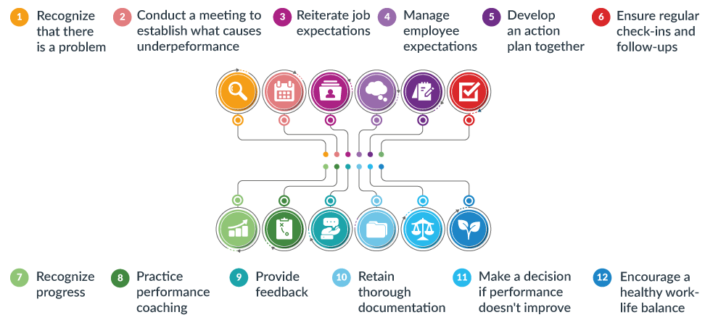

1. Recognize that there is a problem

2. Conduct a meeting and ask questions to establish what causes the employee to underperform

3. Reiterate job expectations

4. Manage employee expectations

5. Develop an action plan together

6. Ensure regular check-ins and follow-ups

7. Recognize progress

8. Practice performance coaching

9. Provide feedback

10. Retain thorough documentation

11. Make a decision if performance doesn’t improve - Reassignment | Move out

12. Encourage a healthy work-life balance

Although dealing with underperformance can be a time-consuming process, most underperforming employees will embrace a collaborative effort that coaches them to do their job better.

**What traits does a good employee need to succeed?**

The top qualities for the best employees are: -

1. Confident. Confident employees make their employer feel confident. ...
2. Sportive Team player
3. Reliable
4. Prepared
5. Organized
6. Good communicator
7. Self-disciplined
8. Flexible
9. Socially intelligent
10. Passionate. Passion, ambition, drive. ...

**Tell me about a time when you had to make a tough business decision that supported your company’s purpose, but may have had a negative, short-term financial impact?**

**People | Technology | Client**

In my recent project, there was a DR setup that I had to implement for a client. The architects of the client suggested go active-active (i.e., deployed in two regions).

With scalable up-to 100% on each zone but I put my foot down and had several tough conversations from architects to the project management to the senior executives of the client and to my internal technical team and management.

My suggestion was to go active- active across three zones. This was slightly on the expensive side. Slightly 15% expensive than the original active-active solution proposed by the client.

Finally, I was able to convince them though the client took a hit financially in the short term. There was a major outage on AWS cloud, which made both the originally proposed zones unavailable.

As we implemented the solutions across three zones, we were able to move all traffic to the third zone and avoided a major muti hour outage to the client. Thus, saving few million dollars on the SLA penalties.

**If you could work on solving any problem in the world, what one problem would it be?**

I would want to solve the last mile connectivity issues in India.

**How do you motivate your employees in tough times?**

To motivate Employees In Difficult | Tough Times: -

1. Give Them Vision. ...
2. Don't Hide The Target. ...
3. Provide Regular Feedback. ...
4. Make Employees Part Of The Solution. ...
5. Focus On People Development. ...
6. Communicate! ...
7. Don't Overlook The Power Of Praise. ...
8. Build Fun
9. Be Positive

**How do you delegate an important assignment to others while ensuring that it will be completed successfully?**

To Delegate Tasks Effectively:-

1. Choose the right person for the job. ...
2. Explain why you're delegating. ...
3. Provide the right instructions. ...
4. Provide resources and training. ...
5. Delegate responsibility *and* authority. ...
6. Check the work and provide feedback. ...

**How would you go about delivering bad news or a decision that will not be popular?**

When it's time to deliver bad news to employees, follow these steps to ensure you're prepared and confident:

1. Research and prepare
2. Practice
3. Avoid small talk
4. Use direct language
5. Provide context
6. Give time for a response
7. Establish next steps

**When you enter a new workplace with new employees, how would you go about gaining rapport with them?**

To Build Rapport with New Colleagues: -

1. Establish a Common Ground. The first step to building a connection with your new colleagues is identifying common ground. ...
2. Practice Courtesy and Listen to Your Colleagues. ...
3. Be Authentic about Yourself. ...
4. Spend Time with Your New Colleagues. ...
5. Embrace Teamwork and Offer Help

**Describe how you would manage your work week?**

1. Plan Out Your Week Ahead of Time. Laying out a long term schedule for yourself at the beginning of each work week can help you visually see what tasks lay ahead of you. ...
2. Schedule Tomorrow Today. ...
3. Consider the Times of Day You Work Best. ...
4. Find Tools That Work for You.

**How to handle different personalities at work?**

To effectively engage with different personality types in the workplace:-

1. Know what the differences are and avoid negative labelling. ...
2. Recognize cultural differences. ...
3. See people objectively, not personally. ...
4. Embrace difference: ask questions. ...
5. Look for the common agenda or goal. ...
6. Respect yourself and pick your battles.

**How would you handle a decision that you made that did not have the affect that you were expecting to achieve?**

By doing the root cause analysis, it will help to identify the issues and do course correction at frequent intervals.

**How would you go about disagreeing with your supervisor about a decision that you know is not the right one?**

Tell Me About a Time You Disagreed With Your Boss

1. Choose the right story. ...
2. Admit that you disagreed with your boss. ...
3. Explain what your responsibility was. ...
4. Explain the conflict. ...
5. Explain what action you took to resolve the issue. ...
6. Explain how or why it didn't happen again.

**You are at a point with an employee that it is best to have them leave the organization. How would you go about the conversation?**

**General Procedures**

* Creating your employee resignation checklist in the Project Account as well as in the org. portal
* Inform HR that the employee is resigning
* Make plans for the employee to finalize or transition projects to the other team members
* Distribute employee's work and responsibilities to current employees until a replacement can be found
* Request open headcount to replace the departing employee asap

**5 Ways to Stop a Valued Employee from Quitting**

* Talk It Out
* Show Appreciation
* Offer Support
* Put Career Goals in Reach
* Invest in Employee Retention

**Situation to explain the Non-Billable Position to employees**

I am very sorry to say that your positions is eliminated and I would not be able to accommodate you in other projects as well. The main reason for this client has reduced their headcount, so I forced to take the decisions.

## 6. Program Governance

Program Governance is the performance domain that enables and performs program decision making, establishes practices to support the program, and maintains program oversight. It includes:

* Program Governance Practices
* Program Governance Roles
* Program Governance Design and Implementation

Program Governance comprises the framework, functions, and processes by which a program is monitored, managed, and supported in order to meet organizational strategic and operational goals.

Management plans, builds, runs and monitors activities in alignment with the direction set by the governance body to achieve the enterprise objectives.

**Effective program governance supports the success of a program by: -**

* Ensuring that the goals of the program remain aligned with the strategic vision, operational capabilities, and resource commitments of the sponsoring organization. Compliance with the reporting and controlling processes required to support this alignment is enforced by the Program Governance domain;
* Approving, endorsing, and initiating the program and securing funding from the sponsoring organization;
* Establishing clear, well-understood agreements as to how the sponsoring organization will oversee the program, and conversely, the degree of autonomy that the program will be given in the pursuit of its goals;
* Facilitating the engagement of program stakeholders by establishing clear expectations for each program’s interactions with key governing stakeholders throughout the program;
* Creating an environment for communicating and addressing program risks and uncertainties to the organization, as well as opportunities and issues that arise during the course of program performance;
* Providing a framework that is aligned with portfolio and corporate governance policies and processes for assessing and ensuring the program is compliant. Each program may need to create a particular governance process or procedure, but it should be aligned with the organization’s governance principles;
* Designing and authorizing the assurance process and, when required, executing reviews and health checks of the program progress in delivering its expected benefits. Various review types are used, including phase-gate reviews, other decision point reviews, and periodic health checks;
* Enabling the organization to assess the viability of the organization’s strategic plan and the level of support required to achieve it;
* Selecting, endorsing, and enabling the pursuit of program components, including projects, subsidiary programs, and other program activities;
* Making decisions to transition between phases, terminate, or close the program.

**Program Governance Domain Elements**

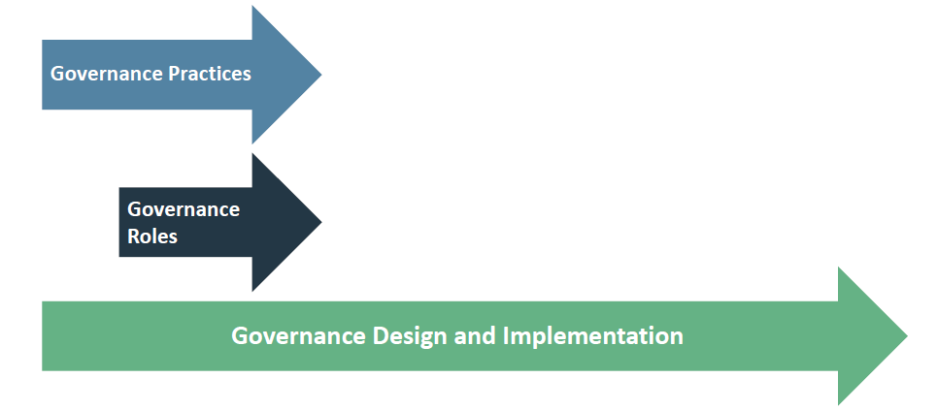

* Program Governance Practices
* Program Governance Plan
* Program Governance and Vision and Goals
* Program Approval, Endorsement, and Definition
* Program Success Criteria
* Program Monitoring, Reporting, and Controlling
* Program Risk and Issue Governance
* Program Quality Governance
* Program Change Governance
* Program Governance Reviews
* Program Periodic Health Checks
* Program Component Initiation and Transition
* Program Closure

**Program Governance Participants**

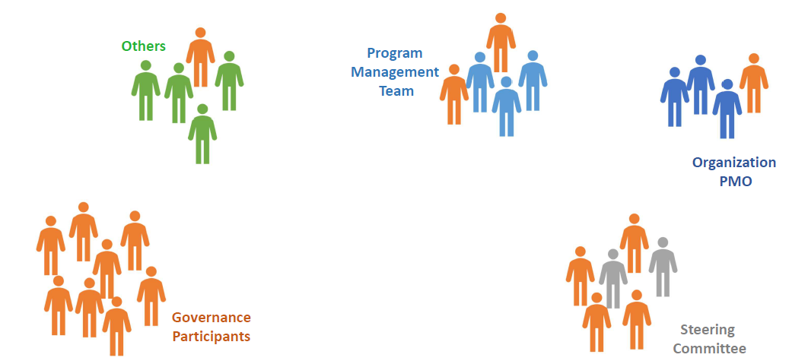

**Major Activities**

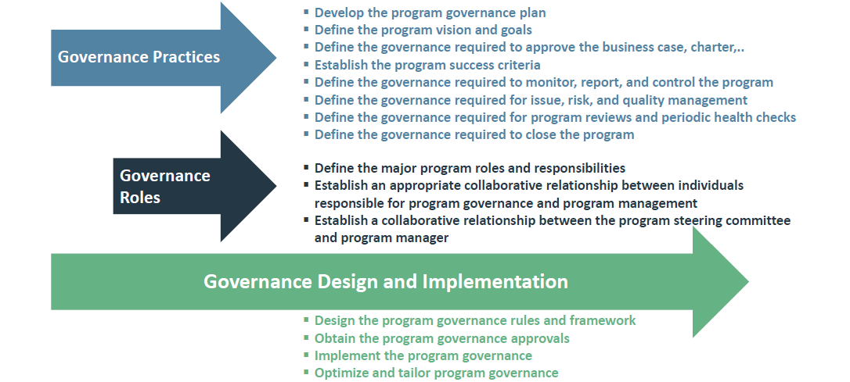

**Major Artifacts**

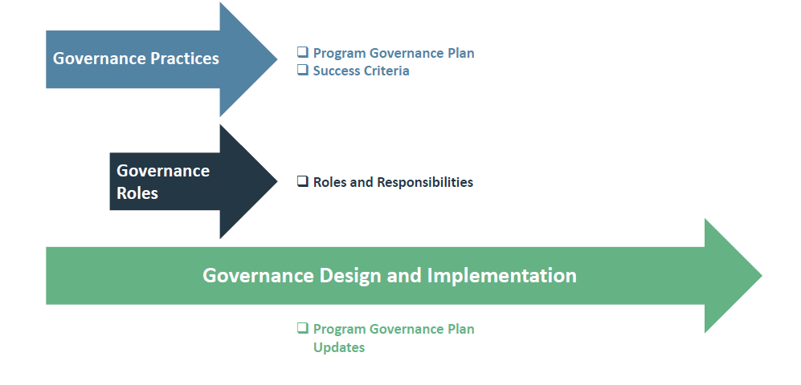

**6.1 Program Governance Practices**

**Program Governance Plan**

The program governance plan include:

* Roles and Responsibilities of the main program organization chart Regular Governance meetings schedule
* List of governance key dependencies, assumptions, and constraints
* List of the methods and metrics
* Description of how information on the components will be collected, consolidated, and reported
* List of the stakeholders who should be engaged and communicated with
* Identification of the areas where governance-related support is needed
* The intended design and implementation of practices

**Success Criteria**

Minimum acceptable criteria for a successful program

Describe the definition of success

Were initially defined in the business case

Reinforce the program alignment to deliver the maximum attainable benefits

**Program Roles and Responsibilities**

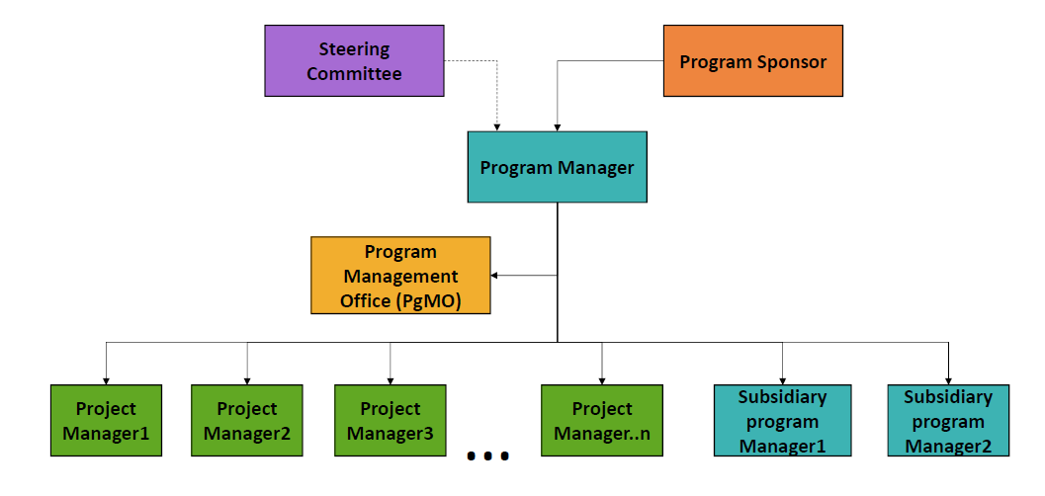

**Review, Health-Check, and Audit**

* Program Review (Decision-point Review)
* Periodic Health Check
* Audit Types:
* First Party
* Second Party
* Third Party

**Review, Health-Check, and Audit**

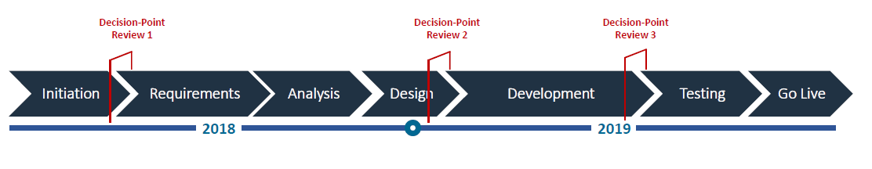

**6.2 Governance**

The program governance is the framework, functions, and processes that guide program management activities in order to deliver benefits to meet organizational strategic and operational goals.

**Four Governance Domains**

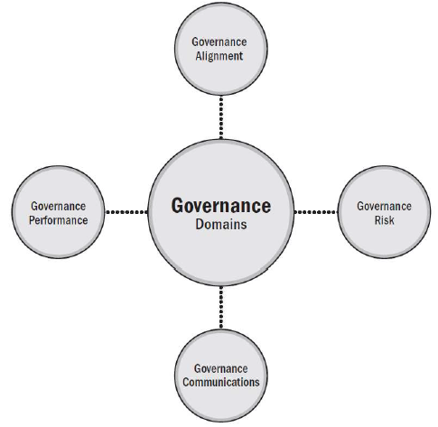

**Four Governance Functions**

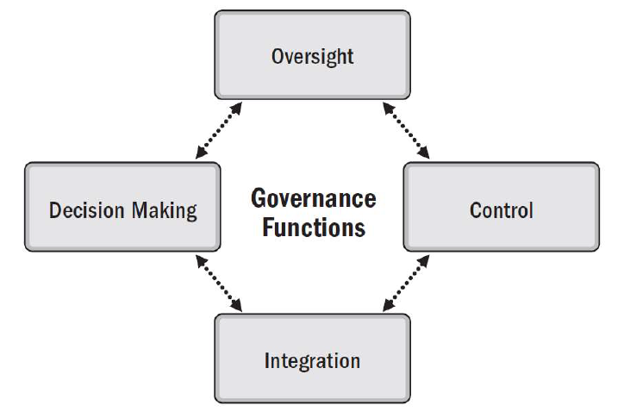

**Governance Framework Implementation**

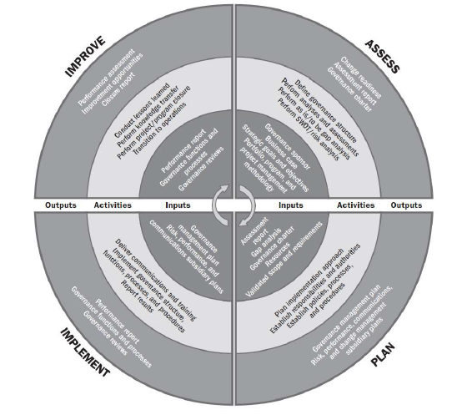

**Program Roles Highlights**

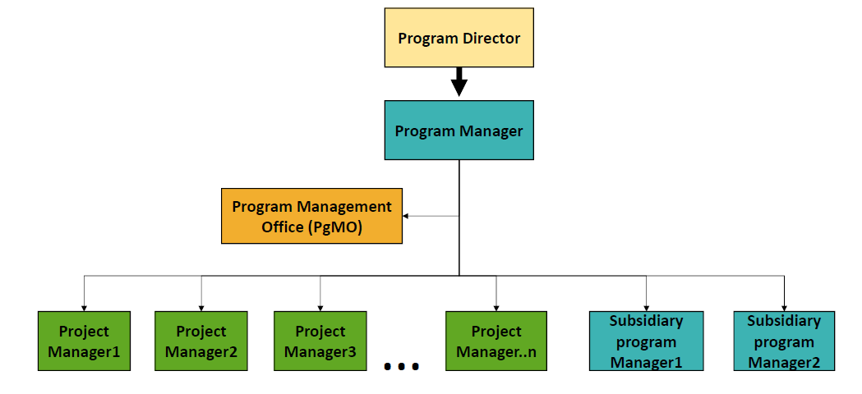

**Program Governance Relationship with Program Life Cycle**

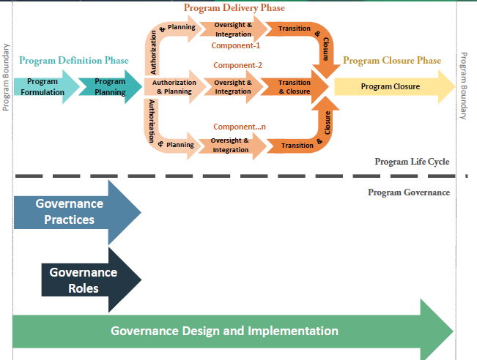

**6.3 Program Governance Design & Implementation**

Program governance begins with the identification of governance participants and the establishment of governance practices. There is also a need to define the specific expectations for how governance-related roles are filled and responsibilities discharged.

Common factors to consider when optimizing and tailoring program governance include:

**Legislative environment:** Programs that are significantly influenced by changing legislation may benefit from governance designed for direct interaction with the legislative authorities. In other cases, the interaction is performed by elements of corporate governance on behalf of the program.

**Decision-making hierarchy:** It is critical for decision-making responsibility to be at the level where competence, accountability, and authority reside. There are complexities to this approach. For example, in organizations where employees are not ultimately accountable for their actions or not made to feel accountable for their actions, there is a greater need for controlling practices. In other circumstances, a highly regarded, successful, and experienced program manager and team may be given greater autonomy and decision-making powers than is typically given to program managers.

**Optimized governance:** Generally, it makes sense for the size of the program governance to be optimized and to be as streamlined as possible, while still able to perform the practices of the domain. This will lead to role clarity, effective and targeted support from the organization, and ultimately more rapid and effective decision making, endorsements, and approvals. Program governance should not duplicate program management activity.

**Alignment with portfolio and organizational governance:** Program governance is impacted by the portfolio governance that it supports. The degree to which program governance should align with organizational governance is based on the number, type, and relative importance of the program governance’s interactions with corporate groups and governance. Typically, the need for alignment with organizational governance is greatest in the program definition stage as the program governance and the program itself are being formulated.

**Program delivery:** A program that regularly delivers benefits to the organization is likely to require different governance than a program delivering all or most of the benefits at the end. Regular delivery of benefits potentially requires constant change in the operations of the organization and the governance to manage this change is critical throughout the life cycle.

**Contracting:** A program being managed and staffed by employees of the receiving organization is likely to require a different level of governance than a program being delivered by an external party when, in such cases, the management of the legal agreement requires a different governance focus.

**Risk of failure:** The greater the perceived risk of program failure, the greater the likelihood the governance team will monitor progress and success more diligently. This may manifest in a higher frequency of health checks and less decision-making delegation to the program team.

**Strategic importance:** High-value programs critical to the success of the organization and delivering benefits that need to be completely aligned with the strategy may require different or more senior participants on the governance team.

**Program management office (PMO):** In many project- or program-based organizations, a centralized PMO supports the governance of all programs for that organization. In other organizations, PMOs may be formed specifically for a given program.

**Program funding structure:** When funding is secured from outside the delivery organization, for example from the World Bank, there are likely implications on the design of the governance and the skills required.

## 7. Program Life Cycle Management

Program Life Cycle Management is the performance domain that manages program activities required to facilitate effective program definition, program delivery, and program closure.

**Program Life Cycle Management Domain**

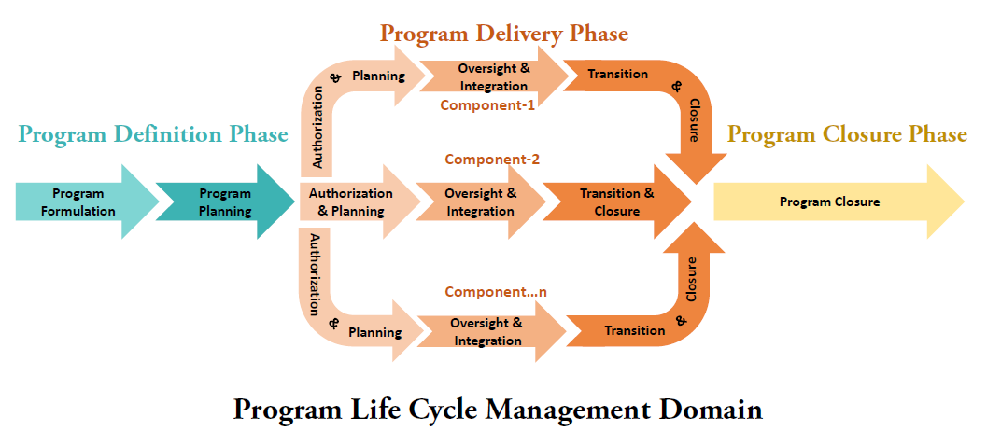

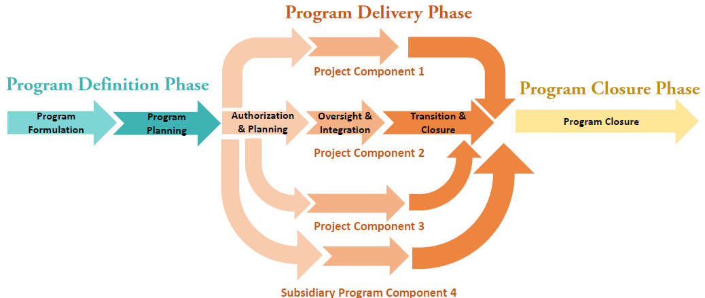

**Program Life Cycle Management - Major Program Activities**

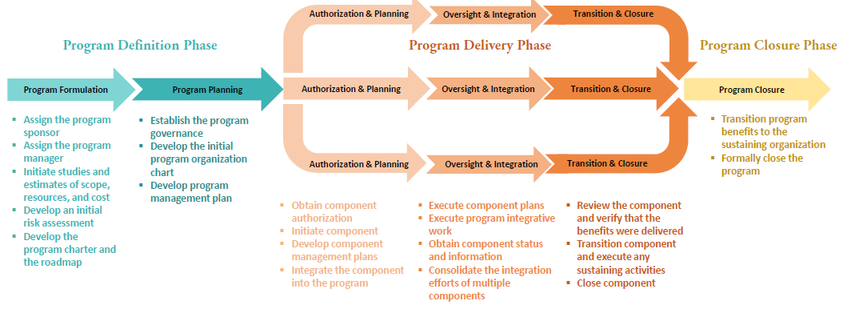

**Program Life Cycle Management - Major Program Artifacts**

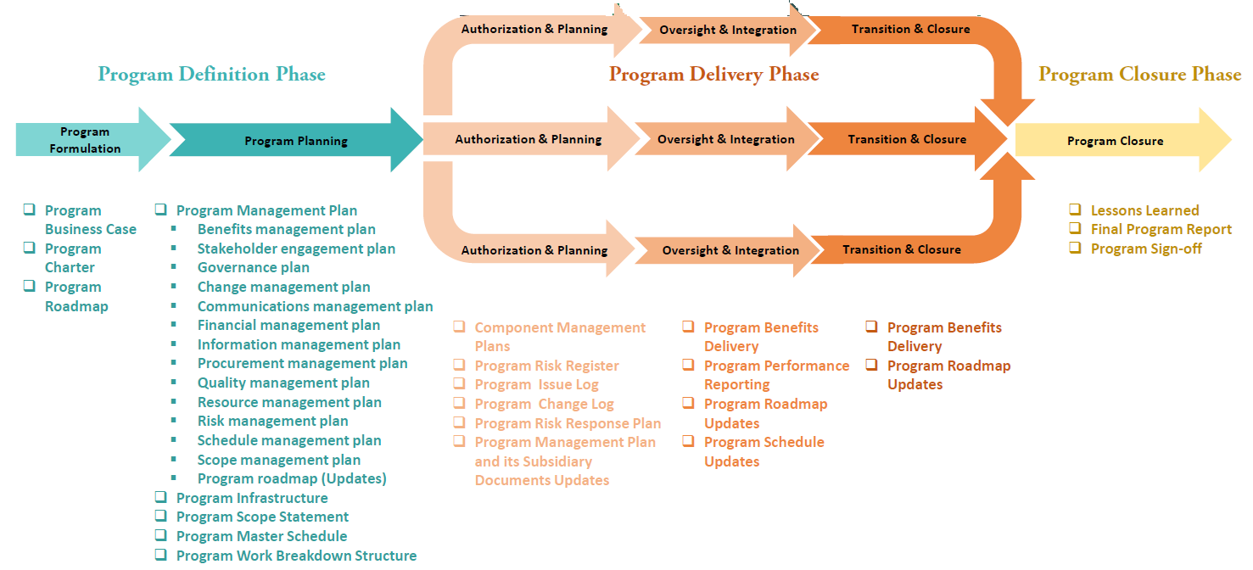

**Program Management Plan**

* Benefits management plan
* Stakeholder engagement plan
* Governance plan
* Change management plan
* Communications management plan
* Financial management plan
* Information management plan
* Procurement management plan
* Quality management plan
* Resource management plan
* Risk management plan
* Schedule management plan
* Scope management plan
* Program roadmap

**Relationship with the Project Management PG’s**

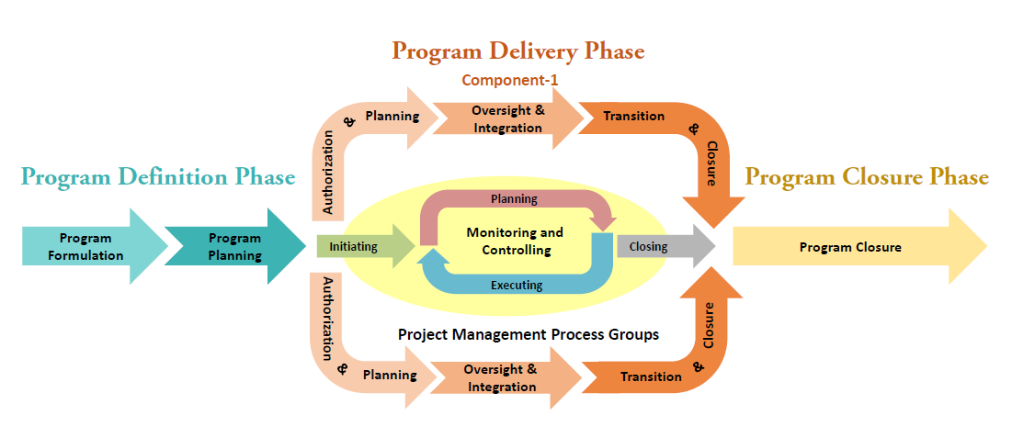

**Component Project - Major Artifacts**

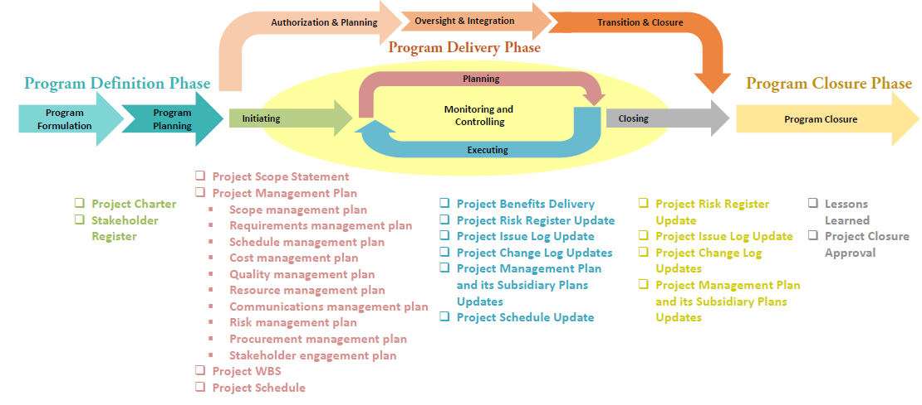

**Relationship with Subsidiary Program Life Cycle**

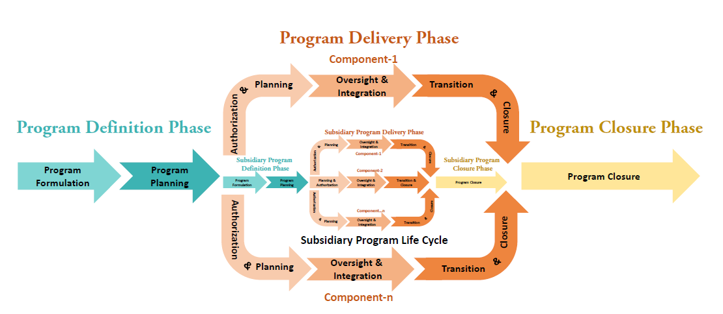

**Component Subsidiary Program - Major Artifacts**

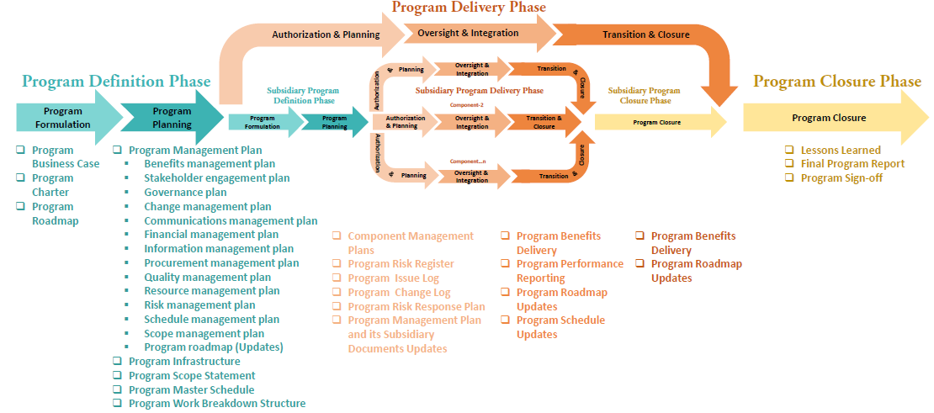

**Program Components Example**

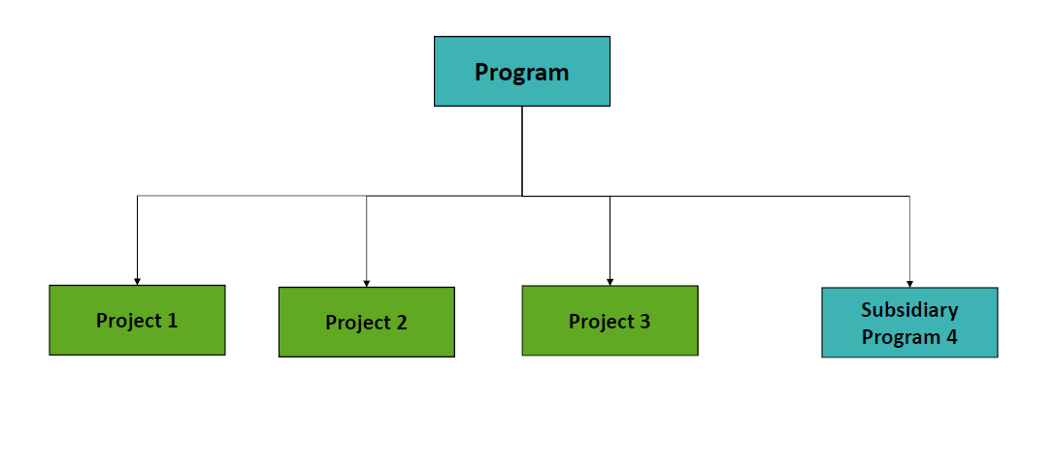

**Program Component’s Execution**

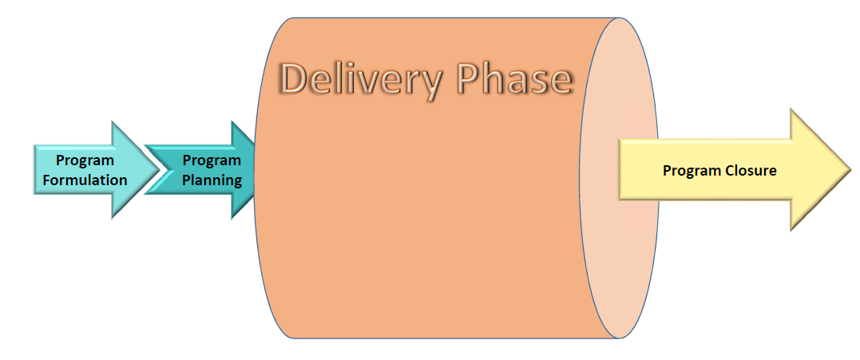

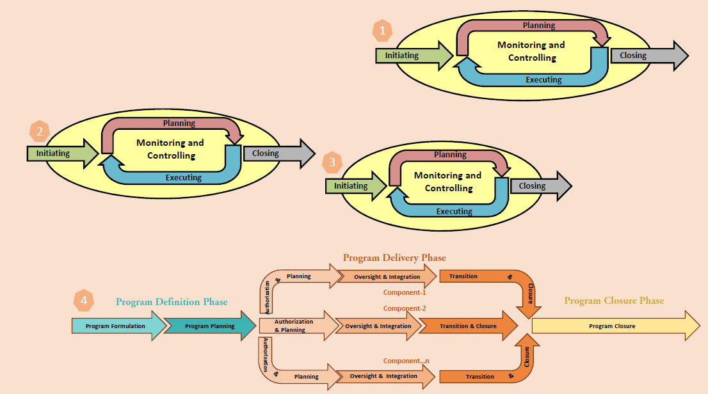

**Program Relationships**

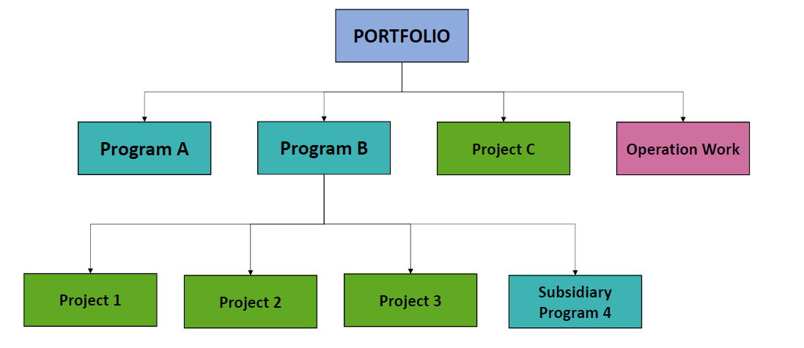

**Portfolio Management Life Cycle**

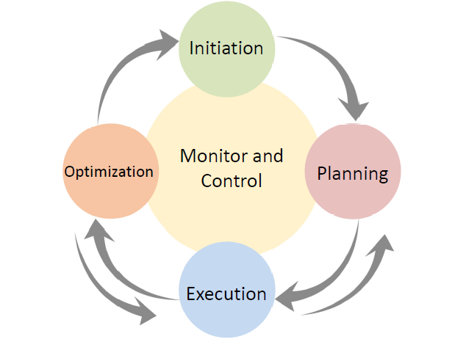

**Relationship with Portfolio Management Life Cycle**

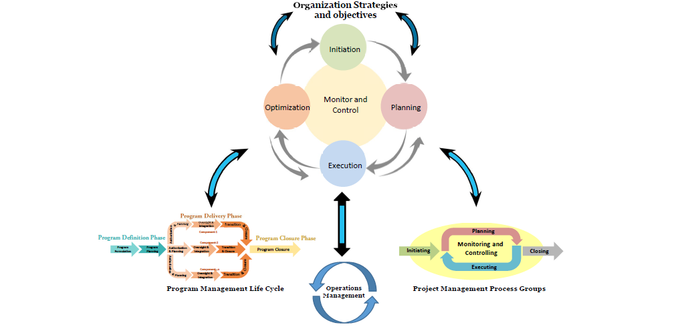

## 8. Program Integration Management

**Program Infrastructure Development**

* Program Organization Chart
* Program Management Office (PgMO)
* Program Management Information System (PMIS)

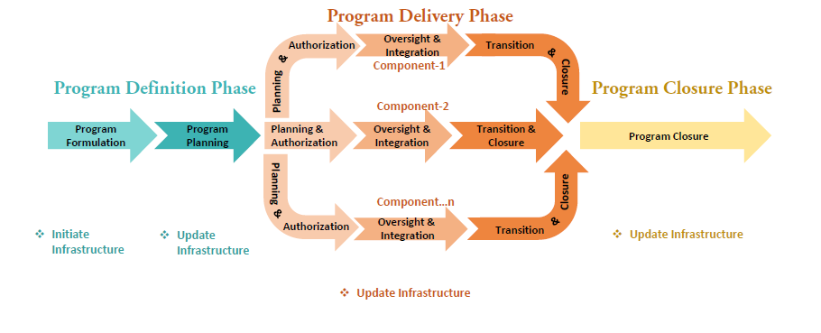

**Program Delivery Management**

* Initiate a new program component
* Change requests
* Close or transition a program component

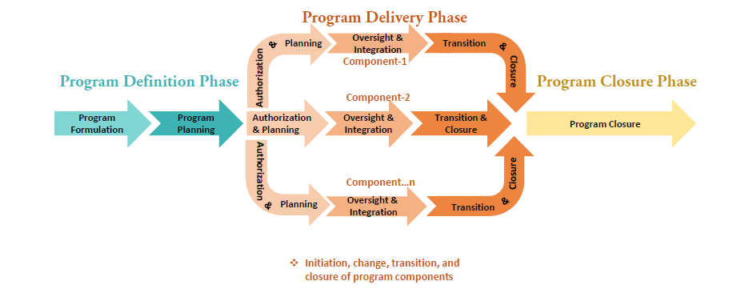

**Program Performance Monitoring & Controlling**

* Performed at both program level and component level
* Monitoring activities: collecting and measuring performance information, track progress against, and assess overall program trends
* Controlling activities: corrective or preventive actions
* Escalations to the program steering committee
* Program performance reports

**Program Performance Monitoring & Controlling**

* Benefits Sustainment and Program Transition
* Benefits sustainment
* Program transition

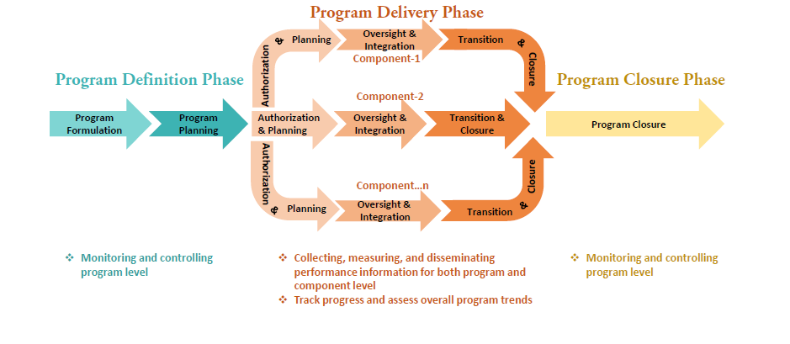

**Benefits Sustainment and Program Transition**

* Program Closeout
* Program closing conditions
* Successful program completion
* Lessons learned and resource release
* Final report

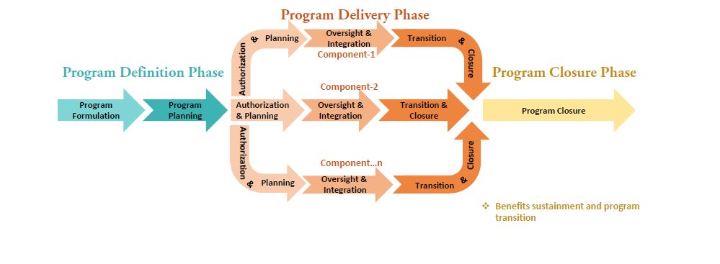

**Program Closeout**

* Program closing conditions
* Successful program completion
* Lessons learned and resource release
* Final report

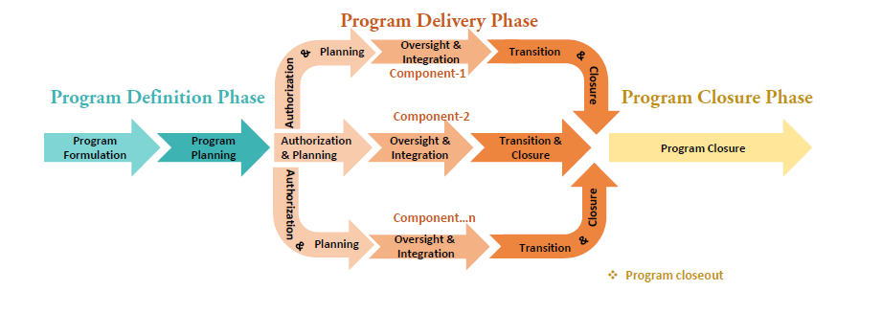

## 9. Program Management Supporting Process

The program level supporting processes enable a synergistic approach for the purpose of delivering program benefits. Like project management supporting process, program management supporting process require coordination with functional groups in the organization.

**Program Activities**

|  |  |
| --- | --- |
| * Program Change Management * Program Communications Management * Program Financial Management * Program Information Management * Program Procurement Management * Program Quality Management | * Program Resource Management * Program Risk Management * Program Schedule Management * Program Scope Management |

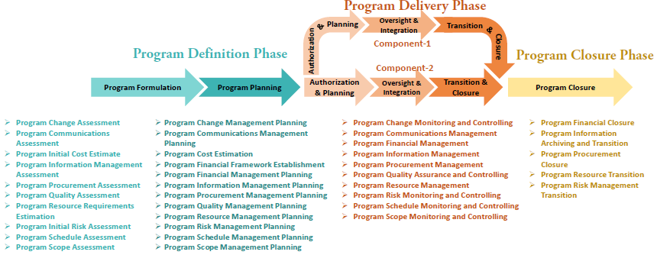

**Program Supporting Activities**

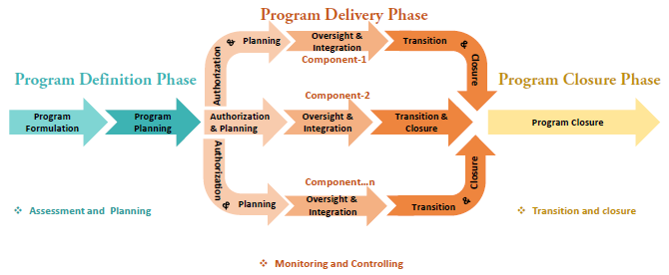

**Program Change Management**

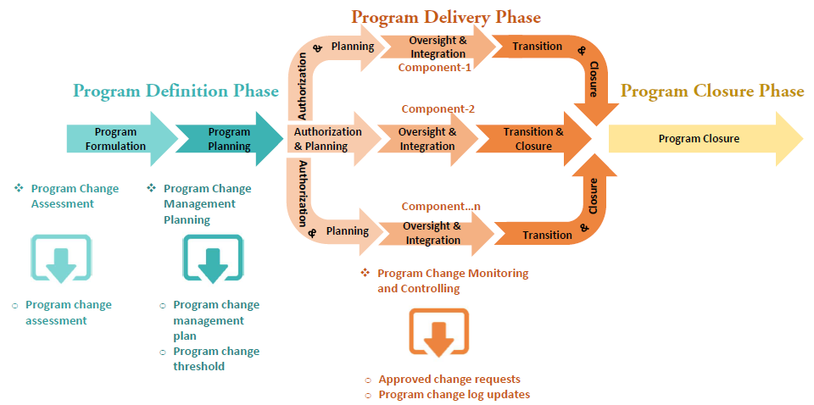

**Program Financial Management**

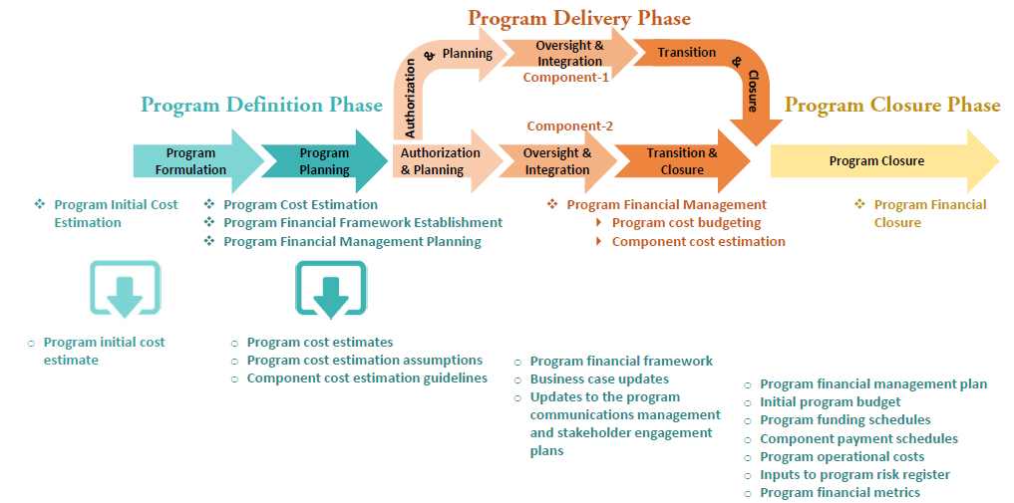

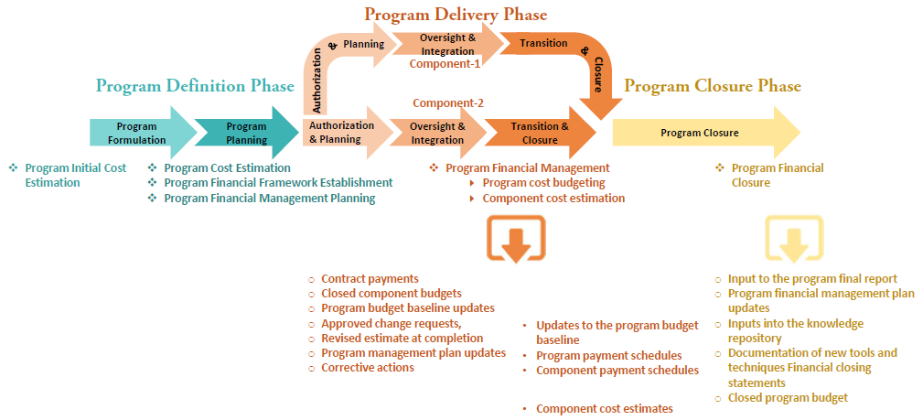

**Program Communications Management**

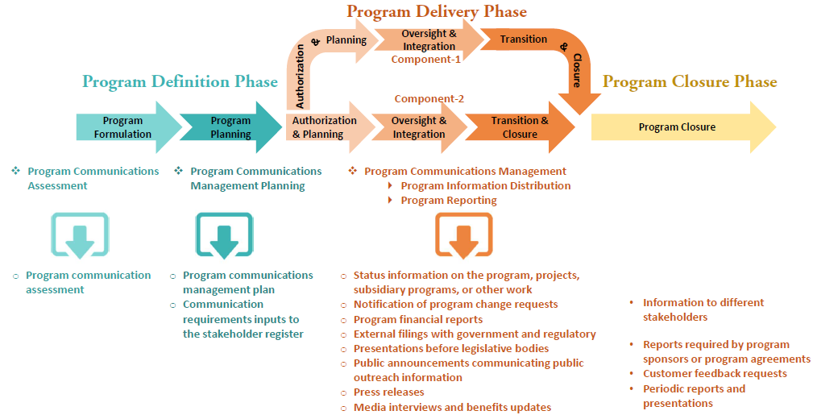

**Program Information Management**

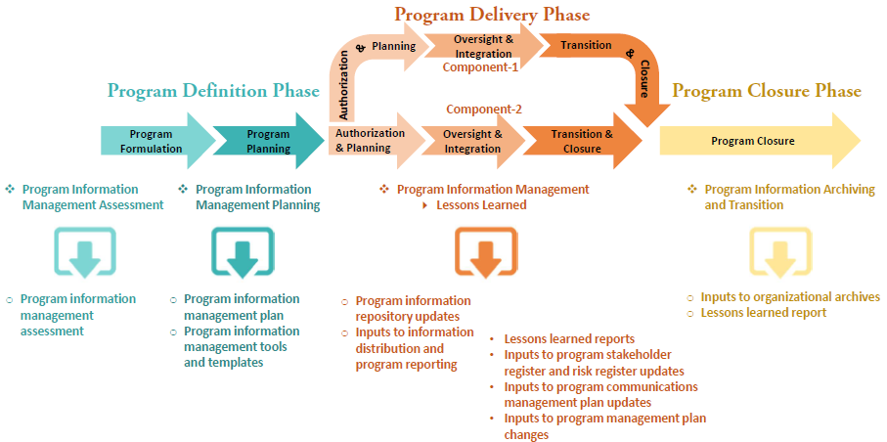

**Program Procurement Management**

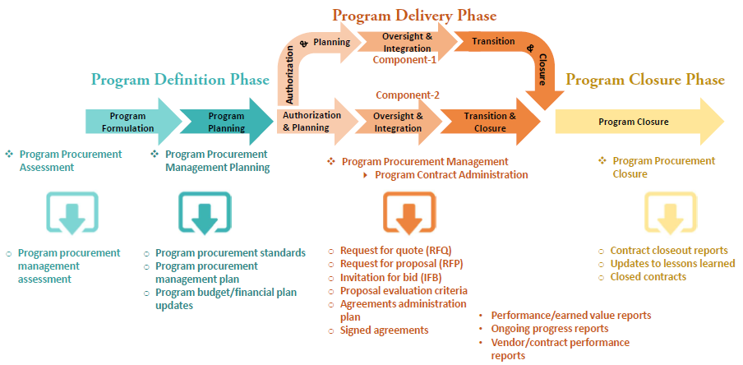

**Program Quality Management**

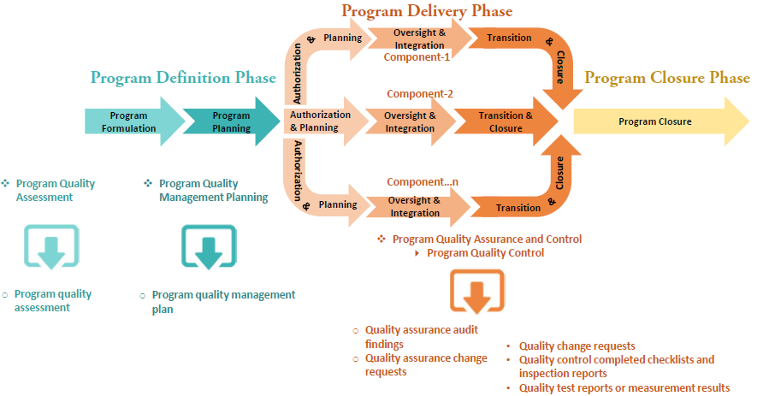

**Program Resource Management**

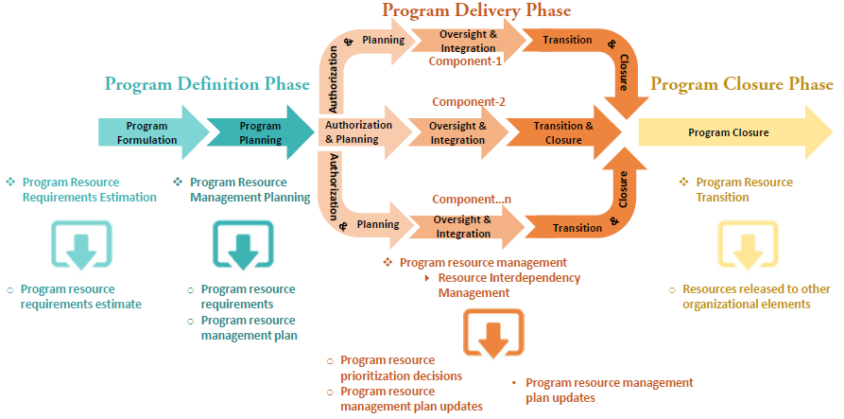

**Program Risk Management**

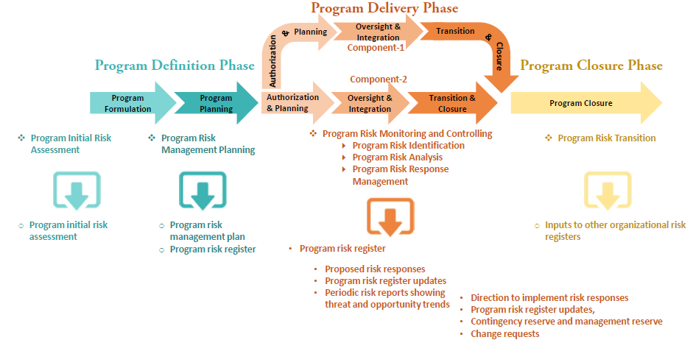

**Program Schedule Management**

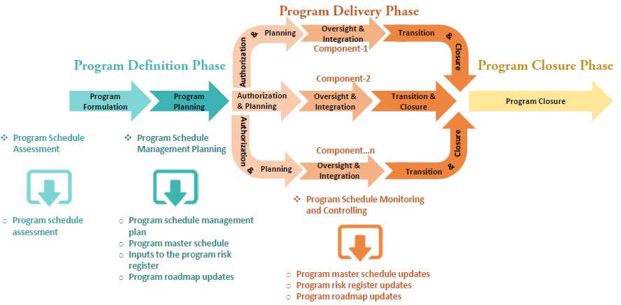

**Program Scope Management**

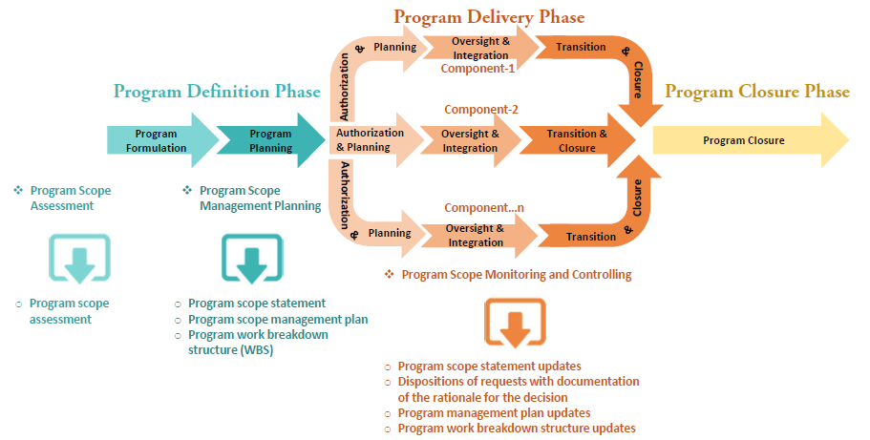

**Program Artifacts**

* Program management plans
* Program issue and Risk registers
* Program master time schedule
* Program benefits realization
* Program work breakdown structure
* Program constraints and assumptions
* Program status reporting
* Program decision request

## 10. Program Management Glossary

**Benefit.** The gains and assets realized by the organization and other stakeholders as the result of outcomes delivered by the program.

**Benefits Management Plan.** The documented explanation defining the processes for creating, maximizing, and sustaining the benefits provided by a project or program.

**Benefits Analysis and Planning Phase.** Establishes the program benefits management plan and develop the benefits metrics and framework for monitoring and controlling both the components and the measurement of benefits within the program.

**Benefits Delivery Phase.** Ensures that the program delivers the expected benefits, as defined in the benefits management plan.

**Benefits Identification Phase.** Analyses the available information about organizational and business strategies, internal and external influences, and program drivers to identify and qualify the benefits that program stakeholders expect to realize.

**Benefits Sustainment Phase.** Ongoing maintenance activities performed beyond the end of the program by receiving organizations to assure continued generation of the improvements and outcomes delivered by the program.

**Benefits Transition Phase.** Program activities that ensure that benefits are transitioned to operational areas and can be sustained once they are transferred.

**Business Case.** A documented economic feasibility study used to establish validity of the benefits to be delivered by a program.

**Component.** A project, subsidiary programs, or other related activities conducted to support a program.

**Constraint.** A limiting factor that affects the execution of a project, program, portfolio, or process.

**Enterprise Environmental Factors.** Conditions, not under the immediate control of the team, that influence, constrain, or direct the project, program, or portfolio.

**Performing Organization.** An enterprise whose personnel are the most directly involved in doing the work of the project or program.

**Phase Gate.** A review at the end of a phase in which a decision is made to continue to the next phase, to continue with modification, or to end a project or program.

**Portfolio.** Projects, programs, subsidiary portfolios, and operations managed as a group to achieve strategic objectives.

**Portfolio Management.** The centralized management of one or more portfolios to achieve strategic objectives.

**Procurement Management Plan.** A component of the project or program management plan that describes how a team will acquire goods and services from outside of the performing organization.

**Program.** Related projects, subsidiary programs, and program activities managed in a coordinated manner to obtain benefits not available from managing them individually.

**Program Activities.** Tasks and work conducted to support a program and which contribute throughout the program life cycle.

**Program Benefits Management.** Processes that clarify the program’s planned benefits and intended outcomes and includes processes for monitoring the program’s ability to deliver against these benefits and outcomes.

**Program Benefits Management Performance Domain.** Performance domain that defines, creates, maximizes, and delivers the benefits provided by the program.

**Program Change Management.** Activities to plan for, monitor, control, and administer changes during the course of the program.

**Program Charter.** A document issued by a sponsor that authorizes the program management team to use organizational

resources to execute the program and links the program to the organization’s strategic objectives.

**Program Closure Phase.** Program activities necessary to transition program benefits to sustaining organization and formally close the program in a controlled manner.

**Program Communications Management.** Activities necessary for the timely and appropriate generation, collection, distribution, storage, retrieval, and ultimate disposition of program information.

**Program Definition Phase.** Program activities conducted to authorize the program and develop the program roadmap required to achieve the expected results.

**Program Delivery Phase.** Program activities performed to produce the intended results of each component in accordance with the program management plan.

**Program Financial Framework.** A high-level initial plan for coordinating available funding, determining constraints, and determining how funding is allocated.

**Program Financial Management.** Activities related to identifying the program’s financial sources and resources, integrating the budgets of the program components, developing the overall budget for the program, and controlling costs during the program.

**Program Governance.** The framework, functions, and processes by which a program is monitored, managed, and supported in order to meet organizational strategic and operational goals.

**Program Governance Framework.** The supporting structure, around which the decision making, supporting, and oversight practices are constructed, operated, and managed.

**Program Governance Performance Domain.** Performance domain that enables and performs program decision making, establishes practices to support the program, and maintains program oversight.

**Program Governance Plan.** A document that describes the systems and methods to be used to monitor, manage, and support a given program, and the responsibilities of specific roles for ensuring the timely and effective use of those systems and methods.

**Program Information Management.** Activities related to how the program’s information assets are prepared, collected, organized, and secured.

**Program Information Management Plan.** A component of the program management plan that describes how the program’s information assets will be prepared, collected, and organized.

**Program Integration Management.** Program activities conducted to identify, define, combine, unify, and coordinate multiple components into the program.

**Program Life Cycle Management.** Managing all program activities related to program definition, program delivery, and program closure.

**Program Life Cycle Management Performance Domain.** Performance domain that manages program activities required to facilitate effective program definition, program delivery, and program closure.

**Program Management.** The application of knowledge, skills, and principles to a program to achieve the program objectives and to obtain benefits and control not available by managing program components individually.

**Program Management Information Systems.** Tools used to collect, integrate, and communicate information critical for the effective management of one or more organizational programs.

**Program Management Office.** A management structure that standardizes the program-related governance processes and facilitates the sharing of resources, methodologies, tools, and techniques.

**Program Management Performance Domain.** Complementary groupings of related areas of activity or function that uniquely characterize and differentiate the activities found in one performance domain from the others within the full

scope of program management work.

**Program Management Plan.** A document that integrates the program’s subsidiary plans and establishes the management controls and overall plan for integrating and managing the program individual components.

**Program Manager.** The individual authorized by the performing organization to lead the team or teams responsible for achieving program objectives.

**Program Master Schedule.** An output of a schedule model that logically links components, milestones, and high-level activities necessary to deliver program benefits.

**Program Procurement Management.** The application of knowledge, skills, tools, and techniques necessary to acquire

products and services to meet the needs of the overall program and the constituent projects/components.

**Program Quality Assurance.** The activities related to the periodic evaluation of overall program quality to provide confidence that the program will comply with relevant quality policies and standards.

**Program Quality Control.** The monitoring of specific components or program deliverables and results to determine if they meet the quality requirements and lead to benefits realization.

**Program Quality Management.** The activities of the performing organization that determine program quality policies, objectives, and responsibilities so that the program will be successful.

**Program Resource Management.** Program activities that ensure all required resources (people, equipment, material, etc.) are made available to the component managers to enable the delivery of benefits for the program.

**Program Schedule Management.** An activity to determine the order and timing of the components needed to produce the program benefits, estimate the amount of time required to accomplish each one, identify significant milestones during the performance of the program, and document the outcomes of each milestone.

**Program Risk.** An uncertain event or condition that, if it occurs, has a positive or negative effect on the program.

**Program Risk Management.** Program activities related to actively identifying, monitoring, analysing, accepting, mitigating, avoiding, or retiring program risk.

**Program Risk Register.** A document in which risks are recorded together with the results of risk analysis and risk response planning.

**Program Roadmap.** A chronological representation of a program’s intended direction that graphically depicts dependencies between major milestones and decision points and reflects the linkage between the business strategy and the program work.

**Program Scope Management.** Activities that define, develop, monitor, control, and verify program scope.

**Program Stakeholder Engagement Performance Domain.** Performance domain that identifies and analyses stakeholder needs and manages expectations and communications to foster stakeholder support.

**Program Strategy Alignment.** Activities associated with the integration and development of business strategies and organizational goals and objectives, and the degree to which operations and performance meet stated organizational goals and objectives.

**Program Strategy Alignment Performance Domain.** Performance domain that identifies program outputs and outcomes to provide benefits aligned with the organization’s goals and objectives.

**Program Steering Committee.** Group of participants representing various program-related interests with the purpose of supporting the program under its authority by providing guidance, endorsements, and approvals through the governance practices. This committee may also be referred to as Program Governance Board.

**Project.** A temporary endeavour undertaken to create a unique product, service, or result.

**Project Management.** The application of knowledge, skills, tools, and techniques to project activities to meet the project requirements.

**Quality Management Plan.** A component of the project or program management plan that describes how an organization’s quality policies will be implemented.

**Risk Management Plan.** A component of the project, program, or portfolio management plan that describes how risk management activities will be structured and performed.

**Schedule Management Plan.** A component of the project or program management plan that establishes the activities for developing, monitoring, and controlling the project or program.

**Scope Management Plan.** A component of the project or program management plan that describes how the scope will be defined, developed, monitored, controlled, and verified.

**Sponsor.** An individual or a group that provides resources and support for the project, program, or portfolio, and is accountable for enabling success.

**Stakeholder.** An individual, group, or organization that may affect, be affected by, or perceive itself to be affected by a decision, activity, or outcome of a project, program, or portfolio.